**B.E. PROJECT REPORT ON**

# CROSS PLATFORM APPLICATION FOR MAJOR PROJECT MANAGEMENT AND TRACKING

SUBMITTED TO THE SAVITRIBAI PHULE PUNE UNIVERSITY, PUNE IN THE PARTIAL FULFILLMENT OF THE REQUIREMENTS

FOR THE AWARD OF THE DEGREE OF

### BACHELOR OF ENGINEERING (COMPUTER ENGINEERING) SUBMITTED BY

**STUDENT NAME: Exam No:**

**NAMDAS PRANOTI ANKUSH B400360699**

**NIRMAL ADITYA SANJAY B400360707**

**PATIL OMKAR SARJERAO B400360727**

**PATIL YASH NILKANTH B400360734**



**DEPARTMENT OF COMPUTER ENGINEERING**

**STES’S SMT. KASHIBAI NAVALE COLLEGE OF ENGINEERING**

VADGAON BK, OFF SINHGAD ROAD, PUNE - 411041

### SAVITRIBAI PHULE PUNE UNIVERSITY

**2024-2025**



## CERTIFICATE

This is to certify that the project report entitles

### “CROSS PLATFORM APPLICATION FOR MAJOR PROJECT MANAGEMENT AND TRACKING”

**Submitted by**

**STUDENT NAME Exam No:**

**NAMDAS PRANOTI ANKUSH B400360699**

**NIRMAL ADITYA SANJAY B400360707**

**PATIL OMKAR SARJERAO B400360727**

**PATIL YASH NILKANTH B400360734**

is a bonafide student of this institute and the work has been carried out by her under the supervision of **Prof. Vrushali Paithankar** and it is approved for the partial fulfillment of the requirement of Savitribai Phule Pune University, for the award of the degree of **Bachelor of Engineering** (Computer Engineering).

**(Prof. Vrushali Paithankar)** External Guide

Guide

Department of Computer

Engineering

**(Prof. R. H. Borhade) (Dr. A. V. Deshpande)**

Head, Principal,

Department of Computer Engineering Smt. Kashibai Navale College Of Engineering, Pune - 41

Date:

Place:

## ACKNOWLEDGEMENT

The present world of competition there is a race of existence in which those are having will to come forward succeed. Project is like a bridge between theoretical and practical working. With this willing we joined this particular project. First of all, we would like to thank the supreme power the Almighty God who is obviously the one has always guided us to work on the right path of life.

We sincerely thank Prof. R. H. Borhade Sir, Head of the Department of Computer Science of Smt. Kashibai Navale college of engineering, for all the facilities provided to us in the pursuit of this project. We are indebted to our project guide Prof Vrushali Paithankar, Department of Computer Engineering of Smt. Kashibai Navale college of engineering. We feel it’s a pleasure to be indebted to our guide for his valuable support, advice and encouragement and we think him for his superb and constant guidance towards this project.

We are deeply grateful to all the staff members of Computer department, for supporting us in all aspects. We acknowledge our deep sense of gratitude to our loving parents for being a constant source of inspiration and motivation.

### NAME OF THE STUDENTS

Namdas Pranoti Ankush

Nirmal Aditya Sanjay

Patil Omkar Sarjerao

Patil Yash Nilkanth

## ABSTRACT

Conventional management tools frequently fail to provide real-time responsiveness, effective resource allocation, and seamless cross-platform support in the context of large-scale project execution. A Cross- Platform Application for Major Project Management and Tracking, created with Flutter, is presented in this paper as a comprehensive solution that guarantees device-agnostic access on desktops, tablets, and smartphones. The system solves important issues with current platforms, such as platform dependency, disjointed team communication, and inefficient task monitoring. The suggested approach uses a hierarchical task delegation model in which project managers give leads tasks to complete and then divide those tasks into smaller, deadline-driven tasks. Team members are always informed thanks to Firebase's real-time updates and notifications, which cut down on misunderstandings and delays. Better tracking of project milestones and the identification of workflow bottlenecks are made possible by the application's sophisticated data visualizations and user-friendly interface. The system maximizes resource utilization, facilitates well-informed decision-making, and improves project workflow transparency through integrated analytics and stringent data security procedures. In order to establish this cross-platform tool as a scalable, effective, and safe substitute for traditional project management services in contemporary, fast-paced settings, this study examines its conception, deployment, and expected effects.

**Keywords**: Flutter Development, Firebase, Cloud, SQL lite, Operations Management, Real-Time Collaboration, Database, Resource Allocation, Team Communication.

## TABLE OF CONTENTS

LIST OF ABBREVATIONS i

LIST OF FIGURES ii

LIST OF TABLES iii

|  |  |  |
| --- | --- | --- |
| **Sr. No.** | **Title of Chapter** | **Page No.** |

|  |  |  |  |
| --- | --- | --- | --- |
| **01** | **Introduction** | | 1 |
| 1.1 | Overview | | 2 |
| 1.2 | Motivation | | 3 |
| 1.3 | Problem Definition and Objectives | | 4 |
| 1.4 | Project Scope & Limitations | | 5 |
| 1.5 | Methodologies of Problem solving | | 6 |
| **02** | **Literature Survey** | | 7 |
| **03** | **Software Requirements Specification** | | 10 |
| 3.1 | Assumptions and Dependencies | | 11 |
| 3.2 | Functional Requirements | | 11 |
|  | 3.2.1 | User Registrations | 11 |
| 3.3 | External Interface Requirements | | 12 |
|  | 3.3.1 | User Interfaces | 12 |
|  | 3.3.2 | Hardware Interfaces | 12 |
|  | 3.3.3 | Software Interfaces | 12 |
| 3.4 | Nonfunctional Requirements | | 12 |
|  | 3.4.1 | Performance Requirements | 12 |
|  | 3.4.2 | Safety Requirements | 13 |
|  | 3.4.3 | Security Requirements | 13 |
|  | 3.4.4 | Software Quality Attributes | 14 |
| 3.5 | System Requirements | | 14 |
|  | 3.5.1 | Database Requirements | 14 |
|  | 3.5.2 | Software Requirements (Platform Choice) | 14 |
|  | 3.5.3 | Hardware Requirements | 15 |
| 3.6 | Analysis Models: SDLC Model to be applied | | 16 |
| **04** | **System Design** | | 18 |
| 4.1 | System Architecture | | 19 |
| 4.2 | Data Flow Diagrams | | 21 |
| 4.3 | Entity Relationship Diagrams | | 23 |
| 4.4 | UML Diagrams | | 24 |
| **05** | **Project Plan** | | 30 |

|  |  |  |  |
| --- | --- | --- | --- |
| 5.1 | Project Estimate | | 31 |
|  | 5.1.1 | Reconciled Estimates | 31 |
|  | 5.1.2 | Project Resources | 31 |
| 5.2 | Risk Management | | 32 |
|  | 5.2.1 | Risk Identification | 32 |
|  | 5.2.2 | Risk Analysis | 32 |
|  | 5.2.3 | Overview of Risk Mitigation, Monitoring, Management | 32 |
| 5.3 | Project Schedule | | 33 |
|  | 5.3.1 | Project Task Set | 33 |
|  | 5.3.2 | Project Timeline | 34 |
| 5.4 | Team Organization | | 35 |
|  | 5.4.1 | Team structure | 35 |
| **06** | **Project Implementation** | | 36 |
| 6.1 | Overview of Project Modules | | 37 |
| 6.2 | Tools and Technologies Used | | 38 |
| **07** | **Software Testing** | | 39 |
| 7.1 | Type of Testing | | 40 |
| 7.2 | Test cases & Test Results | | 41 |
| **08** | **Results** | | 43 |
| **09** | **Conclusions** | | 50 |
| 9.1 | Conclusions | | 51 |
| 9.2 | Future Work | | 51 |
| 9.3 | Applications | | 52 |
|  | **Appendix A**: Problem statement feasibility assessment using, satisfiability analysis and NP Hard, NP-Complete or P type using modern algebra and relevant mathematical models.  **Appendix B**: Details of paper publication: name of the conference/journal, comments of reviewers, certificate, paper.  **Appendix C**: Plagiarism Report of project report. | | 53  56  65 |
| **10** | **References** | | 66 |

## LIST OF ABBREVATIONS

#### Abbreviation Illustration

API Application Programming Interface

CPU Central Processing Unit

ERP Enterprise Resource Planning

GPU Graphics Processing Unit

RAM Random Access Memory

SQL Structured Query Language

SSD Solid State Drive

UI User Interface

|  |  |  |
| --- | --- | --- |
|  | **LIST OF FIGURES** |  |
| **Figure** | **Illustration** | **Page No.** |
| 3.1 | SDLC Model | 16 |
| 4.1 | System Architecture | 19 |
| 4.2 | Data Flow Diagram-0 | 21 |
| 4.3 | Data Flow Diagram-1 | 21 |
| 4.4 | Data Flow Diagram-2 | 22 |
| 4.5 | Entity Relationship Diagram | 23 |
| 4.6 | Component Diagram | 24 |
| 4.7 | Activity Diagram | 25 |
| 4.8 | Sequence Diagram | 26 |
| 4.9 | Use Case Diagram | 27 |
| 4.10 | Deployment Diagram | 28 |
| 4.11 | State MachineDiagram | 29 |
|  |  |  |
|  |  |  |

**LIST OF TABLES**

|  |  |  |
| --- | --- | --- |
| **Table No.** | **Title** | **Page No** |
| 5.1 | Timeline Chart Phase 1 | 34 |
| 5.2 | Timeline Chart Phase 2 | 35 |
| 6.1 | Tools and Technologies used | 38 |
| 7.2 | Test Cases & Test Results | 41 |

# CHAPTER 1 INTRODUCTION

## INTRODUCTION

In an era characterized by rapid technological advancements and dynamic market conditions, effective project management has emerged as a crucial determinant of organizational success. Large-scale projects, often complex in nature and involving multiple teams, present significant challenges that traditional project management tools struggle to address. This limitation often results in inefficiencies, communication breakdowns, and missed deadlines, hindering overall productivity.

To overcome these challenges, we propose the development of a Cross-Platform Application for Major Project Management and Tracking, designed using Flutter. This application aims to provide a streamlined and intuitive solution for managing projects across various devices, including desktops, tablets, and smartphones. By enabling real- time updates, seamless task allocation, and enhanced collaboration among team members, the application seeks to foster a more efficient and responsive work environment.

The application will cater to the needs of project managers, team leads, and employees, ensuring a cohesive and transparent approach to project management. By integrating advanced features such as reporting, analytics, and user-friendly interfaces, this cross-platform application is poised to revolutionize the way organizations manage projects, ultimately driving greater agility and competitiveness in today's fast-paced business landscape.

This application provides a user-friendly interface and powerful visualization capabilities to track the project’s milestones and identify bottlenecks, enabling detailed reports. The integrated analytics offer actionable insights into how the team is performing, resource allocation, and project timeline in order to enhance strategic planning and reduce risks. The communication tools provided within the application minimize time spent on other external platforms, as everything about the project is contained in one place. Data security also forms a paramount aspect of this solution, ensuring that all sensitive project information is protected from unauthorized access.

## MOTIVATION

* **Complex Projects**: Managing large-scale projects requires an efficient tool to handle multiple teams and tight deadlines.
* **Limitations of Existing Tools**: Traditional project management solutions often lack flexibility and real-time capabilities, leading to inefficiencies.
* **Real-Time Collaboration**: Seamless interaction among team members is critical for project success.
* **Cross-Platform Accessibility**: Users need access to management tools across various devices to enhance productivity.
* **User-Friendly Design**: An intuitive interface can improve user adoption and satisfaction.
* **Informed Decision-Making**: Analytics and reporting features provide better visibility into project progress.
* **Scalability:** Organizations need solutions that can grow with them without significant costs.
* **Competitive Edge:** Innovative project management solutions enable organizations to respond effectively to market demands..
* **Manual Tracking and Communication Gaps**: Traditional project management often involves manual tracking, leading to miscommunication and time loss.
* **Challenges in Monitoring and Control :** Lack of structured role-based control makes it hard to monitor performance and project progress.
* **Importance of Mobile Accessibility:** There’s a need for a mobile-first solution to manage tasks anytime, anywhere.
* **Promoting Organizational Efficiency:** This system helps organizations maintain transparency, accountability, and smooth communication across all project stakeholders.

.

## PROBLEM DEFINITION AND OBJECTIVE OF THE PROJECT

### PROBLEM DEFINITION

In businesses and organizations, effectively managing large projects across multiple teams presents critical challenges. Traditional methods often fall short in providing the visibility, control, and accountability needed for efficient project execution. Project managers face difficulties in overseeing timelines, coordinating with team leads, and monitoring task progress, leading to risks of miscommunication, resource inefficiencies, and project delays.

Team leads require a comprehensive solution to break down projects into actionable tasks, assign these tasks to team members, and monitor task progress, ensuring accountability and alignment with organizational goals. Employees need an accessible way to understand task requirements, deadlines, and update their progress, reducing bottlenecks and maintaining clarity throughout the project lifecycle.

The “Cross-platform application for Major Project Management and Tracking” aims to address these issues by providing an organized, cross-platform solution designed to enhance communication, accountability, and visibility across business and organizational projects, supporting effective workflow management and timely project completion.

### OBJECTIVE OF THE PROJECT

The main objectives of the model are: -

* + - * **Streamlined Task Management**: To provide a structured framework for assigning, tracking, and updating tasks among team members, ensuring clarity in responsibilities and deadlines.
      * **Real-Time Collaboration**: To facilitate seamless communication among project stakeholders through integrated messaging and notification systems, enabling timely updates and coordination.
      * **Cross-Platform Compatibility**: To develop a user-friendly application that functions consistently across various devices (desktops, tablets, smartphones), allowing users to access project information anytime and anywhere.
      * **Enhanced Reporting and Analytics**: To incorporate robust analytics and reporting features that provide insights into project progress, resource allocation, helping teams make and optimize project outcomes.

## PROJECT SCOPE AND LIMITATIONS

#### Project Scope

1. **User Management :** The application will support user registration, authentication, and role-based access, allowing project managers, team leads, and employees to interact based on their specific responsibilities
2. **Project and Task Lifecycle :** The scope includes creating, editing, and deleting projects and tasks. Users will be able to assign tasks to team members with detailed descriptions, priorities, and deadlines, facilitating effective project execution.
3. **Real-Time Updates :** The application will provide real-time updates for task assignments, status changes, and approaching deadlines, ensuring that all team members are informed and can respond promptly.
4. **Reporting and Analytics Tools :** The project will include features for generating reports and visualizing project data, enabling teams to track milestones, identify bottlenecks, and assess performance metrics for informed decision-making.

#### Limitations

1. **Dependency on Internet Connectivity :** The application requires a stable internet connection for real-time collaboration and updates, which may hinder access in areas with poor connectivity.
2. **Device Compatibility Issues :** While designed for cross-platform use, variations in device capabilities and screen sizes may lead to inconsistent user experiences or functionality.
3. **User Adoption Challenges :** Transitioning to a new project management tool may encounter resistance from team members accustomed to existing workflows, requiring additional training and support to ensure successful adoption.

## METHODOLOGIES OF PROBLEM SOLVING

1. **Requirement Gathering and Analysis:** We identified the core requirements of the application by understanding the roles and responsibilities of managers, team leads, and employees in project management environments.
2. **Problem Decomposition:** The entire system was divided into smaller modules such as authentication, role-based dashboards, project assignment, task management, and progress tracking for better clarity and modular development.
3. **Role-Based Access Design:** The application logic was structured around different user roles, each with a specific set of functionalities and restricted access to certain modules to ensure proper authorization and task segregation.
4. **Top-Down Design Approach:** A high-level system design was first created, followed by the detailed design and implementation of each individual module. This ensured a clear development roadmap.
5. **Algorithmic Thinking:** Logical functions such as progress percentage calculation, task assignment, and completion status updates were carefully designed to provide accurate and dynamic feedback in real-time.
6. **Agile Development Methodology:** The development process followed an iterative approach, where the application was built in sprints. Each sprint focused on completing and testing a core feature of the system.
7. **Database Modeling:** A structured Firestore database schema was designed to manage user data, project details, task assignments, and real-time progress updates with efficient read/write operations.
8. **Testing and Debugging:** Unit and integration testing were conducted throughout development. Errors were diagnosed using logs and root cause analysis to ensure functional accuracy and system stability.
9. **User Interface Prototyping:** UI designs were planned and developed to offer a responsive and user-friendly experience across multiple devices, ensuring that each role has a clear and simple interaction flow.
10. **Deployment and Maintenance Planning:** Firebase was used for hosting and backend services. Deployment procedures and post-launch maintenance strategies were defined to ensure the system remains scalable and up-to-date.

# CHAPTER 2 LITERATURE SURVEY

* 1. **Paper name**: project management in the cloud: benefits, risks and challenges

**Author**s: Alena k. Kozak, Iryna d. Morozova, Yuliya v. Ryzhkova

**Published in**: journal of management information systems

Abstarct:

This paper explores the integration of cloud computing in project management, focusing on the benefits, risks, and challenges associated with its adoption. The authors conduct a comprehensive literature review and empirical analysis to highlight how cloud-based tools enhance collaboration and efficiency in project execution. The findings indicate that while cloud solutions offer significant advantages such as reduced costs and improved accessibility, organizations must also address concerns related to data security and user adoption to fully leverage these technologies.

* 1. **Paper name**: Cloud Erp: a review of the adoption challenges and benefits

**Authors**: E. Tongsuksai, P. L. Tongsuksai, T. Suksaeng

**Published in**: international journal of information management, 2023

Abstract:

This paper reviews the current landscape of cloud ERP systems, examining the key challenges and benefits associated with their implementation in organizations. Through an analysis of case studies and surveys, the authors identify critical success factors that influence the adoption of cloud ERP, including organizational culture, technology readiness, and security considerations. The paper concludes that while cloud ERP offers scalability and flexibility, organizations must develop comprehensive strategies to overcome implementation hurdles and maximize their investment.

* 1. **Paper name**: the impact of cloud computing on project management: a case study approach

**Authors**: v. Mokar, r. Jain, s. D. Patel

**Published in**: international journal of project management, 2023

Abstarct:

This study investigates the impact of cloud computing technologies on project management practices through a series of case studies across various industries. The authors analyze how cloud-based tools facilitate project planning, execution, and monitoring. The results reveal that cloud computing enhances collaboration, reduces project cycle times, and improves resource allocation. However, the paper also discusses the potential risks associated with cloud dependency and the need for robust data management strategies to mitigate these risks.

* 1. **Paper name**: challenges and opportunities in implementing cloud erp systems

**Authors**: S. Appandairajan, r. Prasad, m. K. Verma

**Published in**: journal of business research, 2024

Abstract:

This paper examines the challenges and opportunities presented by cloud ERP systems in modern businesses. Through a mixed-methods approach, the authors identify the key barriers to implementation, including integration with legacy systems, user training, and data security concerns. The findings suggest that organizations that proactively address these challenges can harness the benefits of cloud ERP, such as improved agility and reduced operational costs. The paper emphasizes the importance of strategic planning and stakeholder engagement in successful cloud ERP adoption.

# CHAPTER 3

**SOFTWARE REQUIREMENTS SPECIFICATION**

## ASSUMPTIONS AND DEPENDENCIES

* **User Accessibility**: Users will have access to compatible devices (desktops, tablets, smartphones) and a stable internet connection.
* **Data Accuracy**: Users will provide accurate and timely information regarding tasks, deadlines, and project updates.
* **Security Compliance**: The application will adhere to relevant data protection regulations and standards.
* **Stakeholder Engagement**: All stakeholders will actively participate and provide feedback during the implementation process.
* **Development Framework**: The application’s performance depends on the Flutter framework.

## FUNCTIONAL REQUIREMENTS

#### User Registration:

* + - * + Users should be able to create an account with a username, password, and email.
        + It should support role-based access, enabling different functionalities for project managers, team leads, and employees.

#### Project and Task Management:

* + - * + Users should be able to create, edit, and delete projects and tasks.
        + The application must allow project managers to assign tasks to team leads, who can further subdivide them for team members with defined deadlines and priorities.

#### Cross-Platform Functionality:

* + - * + The application must work seamlessly across desktops, tablets, and smartphones.

#### Data Security:

* + - * + The application must implement data protection measures, including encryption and regular backups**.**

## EXTERNAL INTERFACE REQUIREMENTS

### USER INTERFACE

* The application should have a clean and intuitive user interface with easy navigation.
* The UI must be responsive and adaptable for desktops, tablets, and smartphones, ensuring a consistent experience across devices.
* It should include user-friendly forms for task and project management, notifications, and reporting.

### HARDWARE INTERFACE

* The application should be compatible with standard hardware configurations, including desktops, laptops, tablets, and smartphones
* It must support touch input for mobile devices and responsive design for various screen resolutions.

### SOFTWARE INTERFACE

* **Platform Required:** Windows / Linux
* **IDE:** VS Code, Android Studio

#### Programming Language: Dart

* **Database:** Firestore, SQLite

## NON-FUNCTIONAL REQUIREMENTS

Non-functional requirements cover all the remaining aspects of a software system that are not addressed by the functional requirements. While functional requirements define what the system should do such as features, tasks, or actions non-functional requirements specify how well those functions must be performed. They set the criteria that judge the quality and operation of a system rather than its specific behaviors. These requirements are essential to ensure the overall usability, performance, and effectiveness of the application under real-world conditions.They specify criteria that judge the operation of a system, rather than specific behaviors, for example: Some typical non-functional requirements are

### PERFORMANCES REQUIREMENTS :

1. **System Response Time:** The application must ensure that user actions (such as loading projects, task creation, and updates) are completed within 2 seconds under normal operating conditions.
2. **Scalability:** The system should be able to handle at least 100 concurrent users without any degradation in performance.
3. **Maintainability:** The codebase should be modular and well-documented, allowing for easy updates and modifications.
4. **Usability:** The application must have an intuitive and visually appealing interface that facilitates easy navigation for all user roles.

### SAFETY REQUIRMENT

* + - 1. **Data Integrity:** The system ensures that all project and task data is accurately stored and not altered or deleted by unauthorized users.
      2. **Access Control:** Role-based access restricts users from performing unauthorized actions, ensuring safe handling of sensitive operations.
      3. **Error Handling:** Proper error messages and fallback mechanisms are implemented to prevent system crashes and guide users during unexpected inputs or failures.
      4. **Data Backup:** Firebase Firestore automatically manages data replication and backup, reducing the risk of data loss.
      5. **Session Safety:** Secure session management is implemented to prevent unauthorized use, especially on shared or public devices.

### SECURITY REQUIREMENT

* + - 1. **Authentication and Authorization:** The system uses Firebase Authentication to ensure that only registered users can log in. Role-based access control is implemented to restrict functionalities based on user roles (Manager, Team Lead, Employee).
      2. **Secure Communication:** All data transmission between the client application and Firebase is encrypted using HTTPS to prevent interception or tampering.
      3. **Data Privacy:** User-specific data is protected by Firebase Security Rules, ensuring that users can only access data relevant to their roles and projects.
      4. **Input Validation:** All input fields are validated on both client and server sides to prevent injection attacks or invalid data entry.

### SOFTWARE QUALITY ATTRIBUTES

* + - 1. **Usability:** The application is designed with a clean and intuitive user interface using Flutter, ensuring ease of navigation and interaction for users with different technical backgrounds.
      2. **Reliability:** The system consistently performs its intended functions, such as task updates and progress tracking, without failure under normal operating conditions.
      3. **Scalability:** By using Firebase as a backend, the system can scale to support more users and projects without major architectural changes.
      4. **Maintainability:** Modular code structure and proper documentation ensure that future updates or bug fixes can be made efficiently.
      5. **Performance Efficiency:** Real-time updates using Firestore ensure minimal latency in data retrieval and synchronization, leading to faster performance.

## SYSTEM REQUIREMENTS

### DATABASE REQUIRMENT

* The application uses Firebase Fire store, a cloud-based NoSQL database that enables real-time data storage and synchronization. It organizes data into collections and documents, supports role-based access control, and scales automatically with growing user and data needs.

### SOFTWARE

* **Operating System:** Windows 10 (Recommended: Windows 11).
* **CPU:** Intel or AMD processor with 64-bit support (Recommended: 2.8 GHz or faster).
* **RAM:** Minimum 8 GB (Recommended: 16 GB).
* **GPU:** Integrated graphics or NVIDIA GeForce GTX 1050 (Recommended: NVIDIA GeForce GT 1660 or Quadro T1000)
* **Internet:** Stable internet connection required.
* **Platform:** Flutter SDK.
* **Development Environment:** Android Studio or Visual Studio Code.

#### Programming Language: Dart.

* **Database:** MongoDB or Firebase.
* **Framework:** Flutter for cross-platform application development.
* **Version Control:** Git for source code management.

### HARDWARE

Some products include both minimum and recommended system requirements. A video game, for instance, may function with the minimum required CPU and GPU, but it will perform better with the recommended hardware. A More powerful processor and graphics card may produce improved graphics and faster frame rates. Some system requirements are not flexible, such as the operating system(s) and disk space required for software installation. Others, such as CPU, GPU, and RAM requirements may vary significantly between the minimum and recommended requirements. When buying or upgrading a software program, it is often wise to make sure your system has close to the recommended requirements to ensure a good user experience.

#### Processor:

Recommended: Quad-core processor for smooth performance during multi- user access

* **RAM**:

Recommended: 16 GB to handle larger projects and complex operations efficiently

#### Storage:

Recommended: 256 GB SSD for faster data access and improved application responsiveness

#### Graphics Card:

Recommended: NVIDIA GeForce GTX 1050 for better visualization features

#### Display:

Recommended: 1920 x 1080 resolution for clearer graphics and more workspace

* **Network Adapter**: Wi-Fi capability for essential internet connectivity and real-time collaboration.

## SDLC MODEL

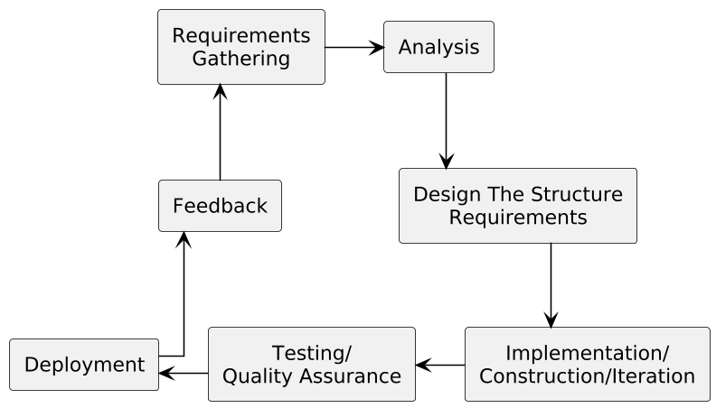

**Fig. 3.1 Agile Model**

The Agile model promotes iterative development and continuous feedback. The following are the sequential phases commonly followed in an Agile development cycle:

1. Requirement Gathering - In this phase, the development team interacts with stakeholders to gather functional and non-functional requirements. The team also estimates the time, cost, and effort required to implement the proposed features. Technical and economic feasibility studies are conducted to ensure the viability of the project.
2. Design the Requirement - This phase involves translating the gathered requirements into design documents. High-level UML diagrams or user-flow diagrams are created to visualize how new features will integrate with the existing system. Wireframes and UI mockups are developed to guide the implementation of user interfaces.
3. Construction / Iteration - During this phase, actual development begins. The team follows an iterative approach, implementing and delivering working features in short development cycles (sprints). The goal is to have a potentially shippable product at the end of each iteration.
4. Testing / Quality Assurance - This phase ensures the product’s reliability, functionality, and performance through various testing methods:
   * **Unit Testing:** Tests individual components or functions to verify correctness in isolation.
   * **Integration Testing:** Ensures that different modules work together as intended.

Example: Verifying that the task assignment module integrates properly with the notification system.

* + **System Testing:** Evaluates the complete system to ensure it meets all specified requirements.

Example: Checking the end-to-end process from project creation to report generation.

* + **User Acceptance Testing (UAT):** Confirms that the application meets user expectations and real-world scenarios. Example: Project managers and team leads verify dashboard usability and report accuracy.
  + **Cross-Platform Testing:** Ensures consistent functionality and user experience across multiple devices. Example: Verifying UI on Android phones, tablets, and desktops.
  + **Performance Testing:** Measures system speed, responsiveness, and stability under load. Example: Ensuring task updates are processed within 2 seconds, even with 100 users.
  + **Security Testing:** Assesses the system’s ability to protect data and enforce access control.

Example: Confirming that unauthorized users cannot access restricted project data.

* + **Unit Testing**: Unit testing is the process of checking small pieces of code to ensure that the individual parts of a program work properly on their own. Unit testing is used to test individual blocks (units) of code.
  + **Integration Testing**: Integration testing is used to identify and resolve any issues that may arise when different units of the software are combined.
  + **System Testing**: Goal is to ensure that the software meets the requirements of the users and that it works correctly in all possible scenarios.

1. Deployment: In this step, the development team will deploy the working project to end users.
2. Feedback: This is the last step of the Agile Model. In this, the team receives feedback about the product and works on correcting bugs based on feedback provided by the customer.

# CHAPTER 4 SYSTEM DESIGN

## SYSTEM ARCHITECTURE

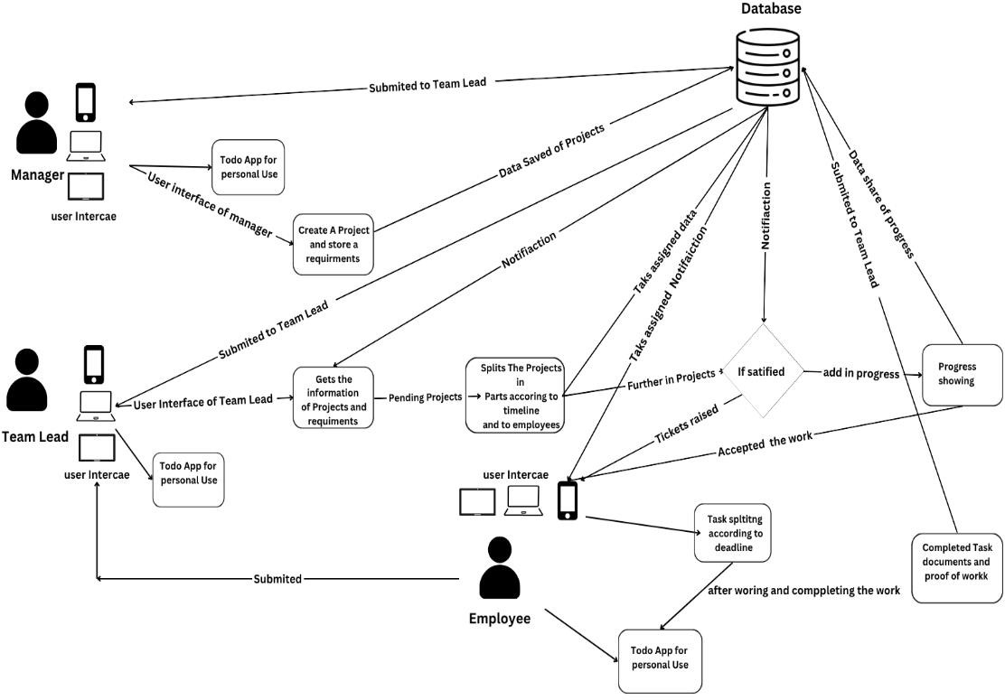

#### Fig 4.1 System Architecture

This system architecture diagram outlines the workflow of an application that involves multiple users, modules, and data interactions. Here's a breakdown of its components and their interactions:

#### User Interaction:

* + Users interact with the system in different roles (e.g., as teachers or project supervisors). The user can input or retrieve information from the system.

#### Input & Authentication (User Side):

* + **Login/Authentication:** Users must authenticate themselves through a login system before accessing various modules. This ensures secure access and user-specific content management.

#### Data Handling and Modules (System Side):

* + **Attendance:** Tracks attendance of students, linked to specific projects or sessions.
  + **Assessment:** Handles the evaluation of student projects. This module integrates with databases to store grades and feedback.
  + **Project/Group Management:** Facilitates the creation and management of student project groups, assigning students to different groups under specific supervisors.
  + **Guide Assignment:** Assigns guides (teachers or mentors) to student projects, facilitating supervision throughout the project lifecycle.

#### Centralized Database:

* + All modules interact with a centralized database for data storage and retrieval. The database stores information on student groups, projects, grades, and user details.

#### Evaluation & Feedback:

* + The **Evaluation** component interacts with both the database and the project/group management system to pull relevant project data for grading. Teachers or supervisors input assessments, which are stored in the database.

#### Output (User Side):

* + The system generates outputs based on the data collected and processed by the modules (e.g., attendance records, project assessments).

This architecture represents an integrated system designed to manage various aspects of a student project lifecycle, including group management, evaluation, and reporting.

## DATA FLOW DIAGRAM

A data flow diagram (DFD) is a graphical representation of the "flow" of data through an information system, modelling its process aspects. A DFD is often used as a preliminary step to create an overview of the system without going into great detail, which can later be elaborated. DFDs can also be used for the visualization of data processing (structured design).

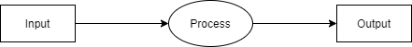

**Fig 4.2 Data Flow Diagram-0**

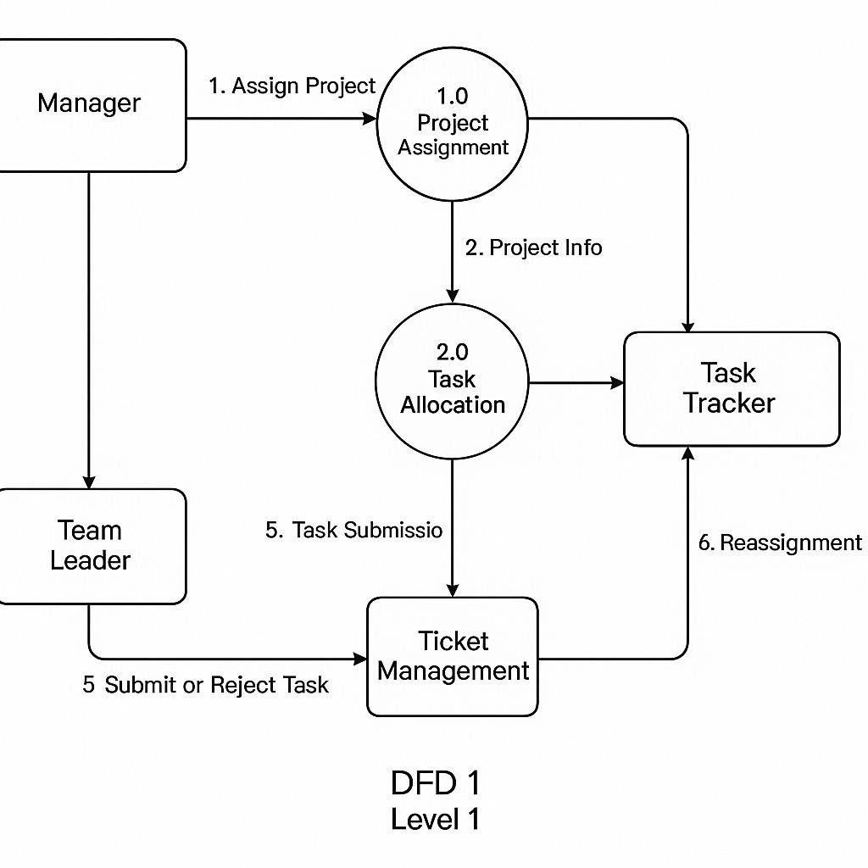

**Fig 4.3 Data Flow Diagram-1**

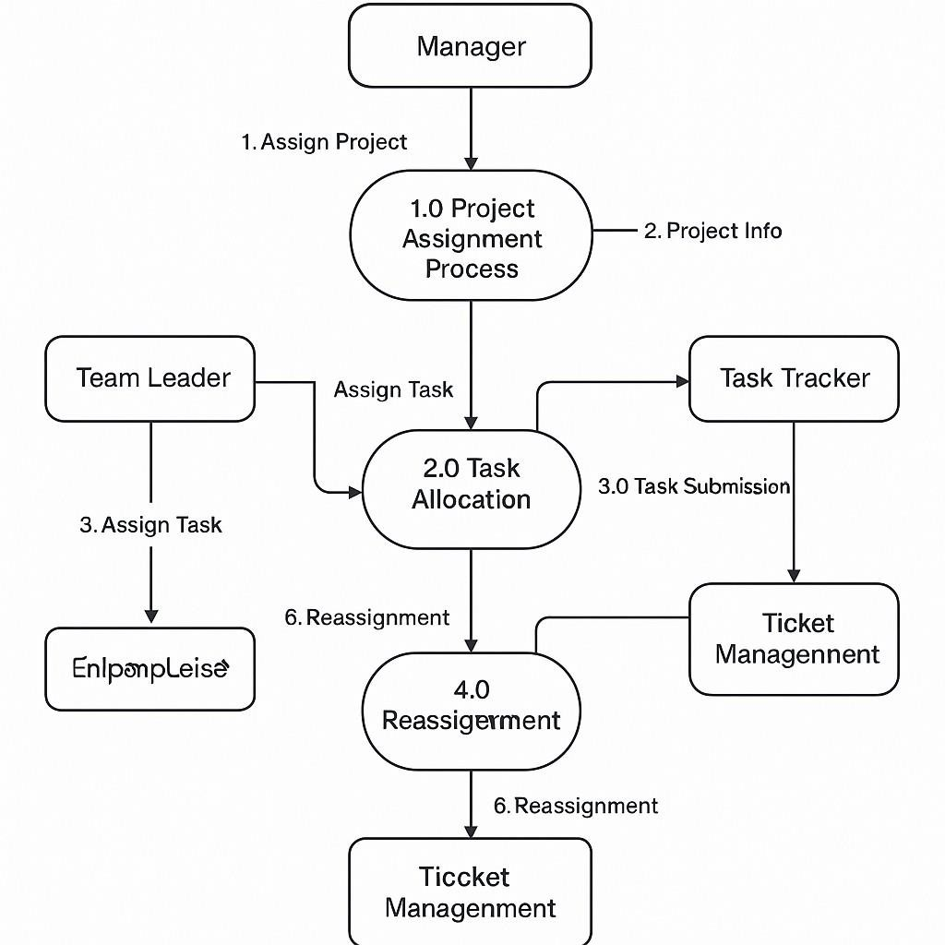

**Fig 4.4 Data Flow Diagram-2**

## ENTITY RELATIONSHIP DIAGRAM

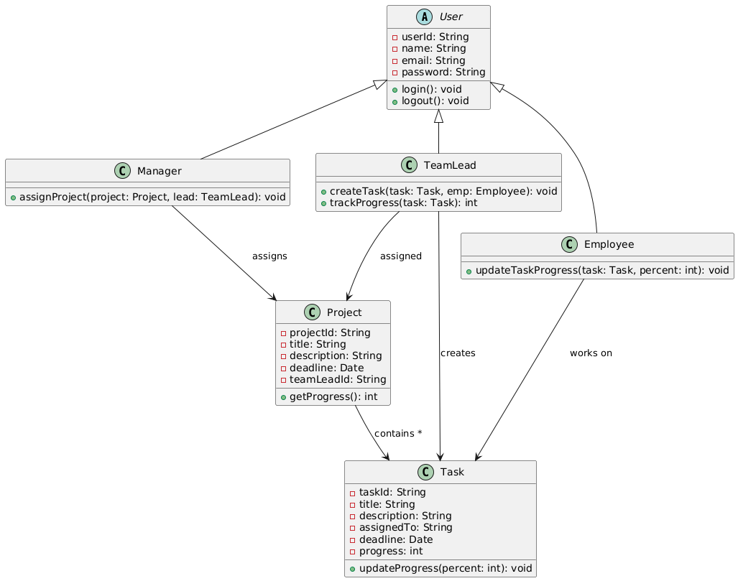

**Fig 4.5 ER Diagram**

## UML DIAGRAMS

#### Component Diagram

A Component Diagram displays the structural relationship of components of a software system. These are mostly used when working with complex systems that have many components. Components communicate with each other using interfaces. The interfaces are linked using connectors**.**

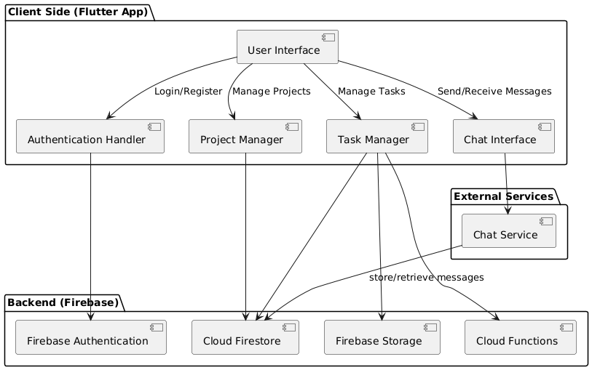

#### Fig 4.6 Component Diagram

* + 1. **Activity Diagram**

An activity diagram visually presents a series of actions or flow of control in a system similar to a flowchart or a data flow diagram. Activity diagrams are often used in business process modelling.



Manager Project assign

Team Lead

Employee

Task Tracker

Task Management

Completion

Progress

Analysis

**Fig 4.7 Activity Diagram**

* + 1. **Sequence Diagram**

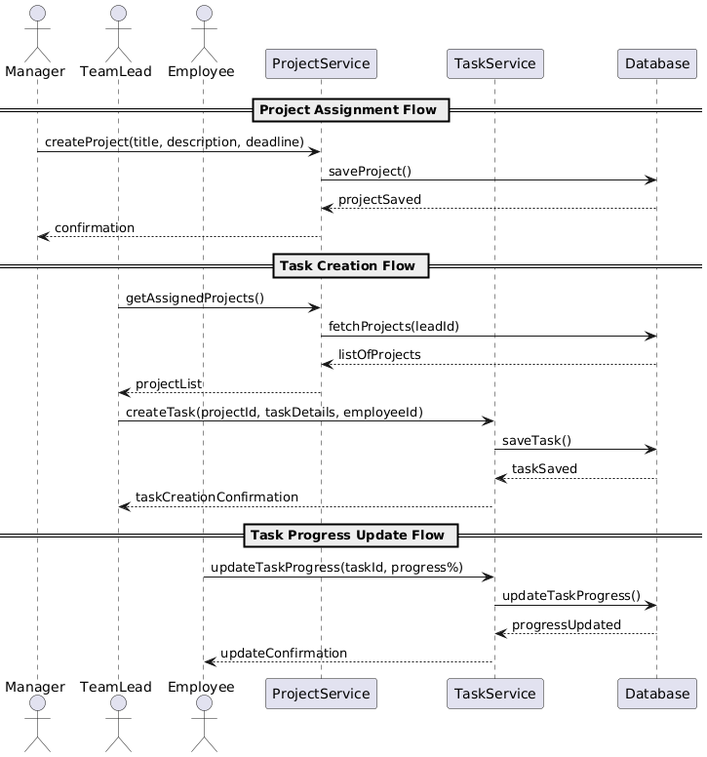

**Fig 4.8 Sequence Diagram**

**CHAPTER 5**

**PROJECT PLAN**

* + 1. **Use Case Diagram**

Use-case diagrams describe the high-level functions and scope of a system. These diagrams also identify the interactions between the system and its actors. The use cases and actors in use-case diagrams describe what the system does and how the actors use it, but not how the system operates internally.

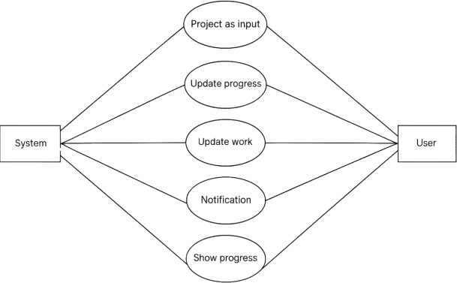

**Fig 4.9 Use Case Diagram**

* + 1. **Deployment Diagram**

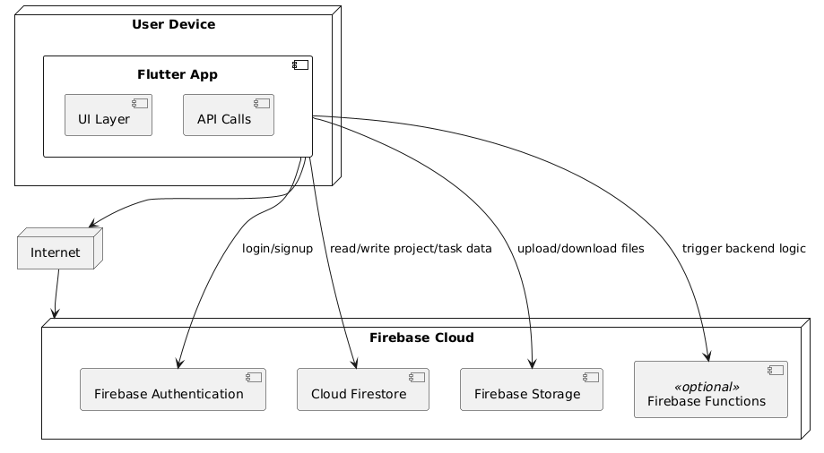

**Fig. 4.10 Deployment Diagram**

**4.4.6 State Machine Diagram**

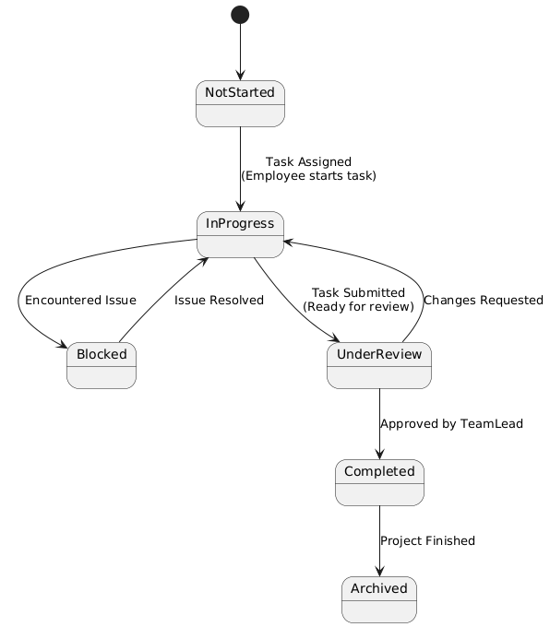

**Fig. 4.11 State Machine Diagram**

# CHAPTER 5 PROJECT PLAN

## PROJECT ESTIMATE

#### Reconciled Estimates Cost Estimate

* + - * Cost will estimate after completing the project that depend on time to complete the

project. Also, efforts required to complete**.**

* + - * WhatsApp messaging service charges are also included in it.

#### Time Estimates

* + - * Time will depend on modules of project.
      * Also, project plan of execution**.**
      * Time can also depend on the donor search speed for requestor.

#### Project Resources

* + - * **Hardware Resources Required:**
        + System: Quad-core processor, 16 GB RAM
        + Storage: Minimum 256 GB SSD
        + Device: Desktop /Laptop

#### Software Resources Required:

* + - * + Operating system: Microsoft Windows.
        + Coding Language: dart
        + IDE: Visual Studio
        + Code Platform: Flutter SDK

## RISK MANAGEMENT

#### Risk Identification

* + - * Assigning specific role to specified user and allow role base authentication and login to system.
      * While accepting data from user there is risk cross site script injection on system.
      * Providing secure and fast communication.
      * Lack of data for training models.
      * More time and resources are required for training.

#### Risk Analysis

* + - * **RISK ID 1**:  
        Firebase Authentication is used for role-based access (Manager, Team Lead, Employee). Misconfiguration in Firebase rules may allow unauthorized access.
      * **RISK ID 2**:  
        During user login or registration, form validation is enforced to ensure proper entries are submitted (e.g., valid email, password strength).
      * **RISK ID 3**:  
        A stable and fast internet connection is required as the app relies on Firebase services like Firestore, Storage, and Authentication.
      * **RISK ID 4**:  
        Firestore chat system, if not optimized (e.g., no pagination or message limits), can cause excessive document reads and degrade performance.
      * **RISK ID 5**:  
        To minimize time and resource constraints, we leveraged Firebase’s integrated backend services (like Firestore and Storage) and prebuilt Flutter packages.

#### Overview of Risk Mitigation, Monitoring, Management

* + - * **Identification of Risks :** Potential risks such as data inconsistency, authentication failures, cloud service outages, and role-based access errors were identified during the planning phase of the project.
      * **Risk Assessment and Categorization :** Risks were assessed based on their likelihood and impact. They were categorized into technical, operational, and user-related risks to prioritize appropriate mitigation strategies.

#### Risk Mitigation Strategies :

* + - * + Implemented Firebase Authentication with secure login protocols to mitigate unauthorized access.
        + Firestore rules and role-based access controls were enforced to

prevent data leaks or misuse.

* + - * + Data is backed up and stored securely using Firebase’s real-time sync and redundancy.
        + Modular coding and testing help isolate failures without impacting the entire system.
      * **Risk Monitoring :** Continuous monitoring was achieved through Firebase’s built- in analytics and Crashlytics tools to detect errors and exceptions in real-time. These tools provide alerts and performance reports.
      * **Contingency and Recovery Planning :** In case of critical service failures, fallback mechanisms such as retry logic, cached data access, and user alerts were designed. User progress data is frequently synced to prevent loss.
      * **Ongoing Management :** Risk reviews were performed at the end of each development sprint. New risks identified during integration or user testing were added to a risk log and mitigated promptly.

## PROJECT SCHEDULE

#### Project Task Set

Major Tasks in the Project stages are:

* + - * **Task 1**: Requirement Analysis and Resource Gathering.
      * **Task 2:** Technology Study (Flutter, Firebase, MongoDB).
      * **Task 3**: Project Specification and Architecture Planning.
      * **Task 4**: Design and Development of Prototype
      * **Task 5**: Design Final User Interface for Cross-Platform Devices.
      * **Task 6**: Coding and Implementation (Develop Manager, Team Lead, and Employee Modules).
      * **Task 7:** Testing and Debugging (Module by Module).
      * **Task 8**: Integration Testing and Final Deployment.
    1. **Project Timeline**

|  |  |  |  |  |  |  |  |  |  |  |
| --- | --- | --- | --- | --- | --- | --- | --- | --- | --- | --- |
| Activity | July | | | August | | | September | | | |
|  | wee k 1 | wee k 2 | wee k 3 | wee k 1 | wee k 2 | wee k 3 | wee k 1 | wee k 2 | wee k 3 | wee k 4 |
| **Initiate the Project** |  | | | | | |  |  |  |  |
| Communication |  |  |  |  |  |  |  |  |  |  |
| Resource Gathering |  |  |  |  |  |  |  |  |  |  |
| Study Technology |  |  |  | | | |  |  |  |  |
| **Plan the Project** |  |  |  |  |  |  |  | | | |
| Project Specification |  |  |  |  |  |  |  |  |  |  |
| Design UML and ER diagram |  |  |  |  |  |  |  |  | |  |
| Design Test Plan |  |  |  |  |  |  |  |  |  |  |

**Table 5.1 Timeline Chart Phase 1**

|  |  |  |  |  |  |  |  |  |  |  |  |  |  |  |  |  |  |  |
| --- | --- | --- | --- | --- | --- | --- | --- | --- | --- | --- | --- | --- | --- | --- | --- | --- | --- | --- |
| Activity | Oct | | | Nov | | | Jan | | | | Mar | | Apr | | | May | | |
|  | week 1 | week 2 | | week 1 | | week 2 | week 1 | | week 2 | week 3 | week 1 | week 2 | week 1 | week 2 | week 3 | week 1 | Week 2 | |
| Execute the Project |  | | | | | | | | | | | | | | | | | |
| Design UI Prototype |  | |  |  |  |  |  |  |  |  |  |  |  |  |  |  |  |  |
| Build Final UI |  | | | |  |  |  |  |  |  |  |  |  |  |  |  |  |  |
| Build the Database |  |  |  |  |  | |  |  |  |  |  |  |  |  |  |  |  |  |
| Build and Test Login |  |  |  |  |  |  |  | | |  |  |  |  |  |  |  |  |  |
| Integrate Database Service |  |  |  |  |  |  |  |  | | |  |  |  |  |  |  |  |  |
| Build and Test User Service |  |  |  |  |  |  |  |  |  |  |  | | |  |  |  |  |  |
| ChatApp |  |  |  |  |  |  |  |  |  |  |  |  |  |  |  |  |  |  |
| Implement Algorithm |  |  |  |  |  |  |  |  |  |  |  |  |  |  | |  |  |  |
| Build and Test Security  Feature |  |  |  |  |  |  |  |  |  |  |  |  |  |  |  |  | |  |
| Documentation |  |  |  |  |  |  |  |  |  |  |  |  |  |  |  |  |  |  |

**Table 5.2 Timeline Chart Phase 2**

## 

## 5.4 TEAM ORGANIZATION

#### 5.4.1 Team Structure

**Responsibilities and duties were distributed among the four members according to their skills.**

• One member was responsible for backend development, managing the server, database, and API integration.  
• Another member focused on designing a responsive and user-friendly interface (frontend) for all devices.  
• A third member handled creating test cases and conducting thorough testing of each module to ensure functionality and performance.  
• The fourth member managed project coordination, including documentation, tracking progress, and ensuring smooth communication among the team. **Management Reporting and Communication.**

# CHAPTER 6 PROJECT IMPLEMENTATION

## OVERVIEW OF PROJECT MODULES

### USER REGISTRATION AND AUTHENTICATION MODULE

Built using Flutter, this module ensures the application functions uniformly across different devices, including desktops, tablets, and smartphones. The responsive UI adapts automatically to different screen sizes and orientations.

#### Cross-Platform Compatibility Module

The admin module allows configuration of system settings, role management, and user permissions. It also supports maintaining system security, backups, and performance optimization.

#### Admin Control and Configuration Module

This module facilitates in-app communication through chat and comments, allowing seamless interaction between managers, leads, and employees. It eliminates dependency on third-party messaging apps and maintains all project discussions within the platform.

#### Communication Module

This module includes charts, graphs, and performance dashboards that help users track project milestones and identify potential bottlenecks. It provides insights into resource utilization and helps with informed decision-making.

#### Reporting and Analytics Module

This module provides real-time updates and alerts for task assignment, updates, and completion. It ensures that all team members stay informed, enhancing collaboration and reducing communication delays.

#### Real-Time Notification and Update Module

This is the core module where projects are created, and tasks are assigned hierarchically. Project managers assign tasks to team leads, who further assign subtasks to individual team members, along with deadlines and priorities. It ensures a smooth flow of responsibilities and tracks progress for each task.

#### Project and Task Management Module

This modules enables users to register and log in to the application. It supports role- based access control ensuring that project managers, team leads and employees access only the features assigned to their roles

* 1. **TOOLS AND TECHNOLOGIES USED**

|  |  |  |
| --- | --- | --- |
| **Category** | **Technology Used** | **Purpose** |
| Frontend | Flutter | Cross-platform UI development for  Android, iOS, and Web |
| Backend & BaaS | Firebase (Firestore, Firebase Auth, Cloud Functions) | Real-time database, authentication, and serverless backend logic |
| Authentication | Firebase Authentication | Role-based secure login and user identity management |
| Database | Cloud Firestore | NoSQL database for storing projects, tasks,  users, and progress data |
| Cloud Storage | Firebase Storage | Upload and manage documents or media associated with tasks or projects |
| Notification System | Firebase Cloud Messaging (FCM) | Real-time push notifications for task assignments and  updates |
| Deployment & Hosting | Firebase Hosting | Hosting the application and related assets |
| Security | Firebase Rules, HTTPS,Role-  based Access | Secure access control, encrypted data flow, and protection from  abuse |
| Version Control | Git, GitHub | Code management, collaboration, and version tracking |

**Table 6.1 Tools and Technologies used**

# CHAPTER 7

# SOFTWARE TESTING

## TYPES OF TESTING

#### Unit Testing

Tests individual functions, components, or modules of the application to ensure that each part works as expected.

*Example:*

Testing the login function to verify if valid and invalid inputs return correct results.

#### Integration Testing

Verifies that different modules or services used by the application work well together.

*Example:*

Checking whether the task assignment module successfully integrates with the notification system.

#### System Testing

Evaluates the complete and integrated software system to ensure it meets the specified requirements.

*Example:*

Testing the full flow from project creation to task assignment, completion, and report generation.

#### User Acceptance Testing (UAT)

Ensures that the application works for end users and satisfies real-world use cases.

*Example:*

Team leads and project managers test the system to confirm that the dashboard, task tracking, and report sections meet their expectations.

#### Cross-Platform Testing

Checks that the application performs consistently across multiple platforms and devices.

*Example:*

Verifying proper UI display and functionality on Android phones, tablets, and Windows desktops.

#### Performance Testing

Measures responsiveness, stability, and speed under specific conditions.

*Example:*

Testing if task creation and updates occur within 2 seconds, even with 100 active users.

#### Security Testing

Evaluates the system’s ability to protect data and maintain functionality as intended.

*Example:*

Ensuring role-based access is enforced and unauthorized users cannot access project data.

* 1. **TEST CASES & TEST RESULTS**

|  |  |  |  |  |  |
| --- | --- | --- | --- | --- | --- |
| **Test case** | **Test Description** | **Input** | **Expected Output** | **Actual Output** | **Status** |
| 1 | Login with valid credentials | Username and password | Dashboard loads successfully | Dashboard loaded | Pass |
| 2 | Login with invalid credentials | Incorrect username/password | Error message shown | Error message shown | Pass |
| 3 | Create new project | Project title, description | Project saved and listed | Project saved and listed | Pass |
| 4 | Assign task to team lead | Select user, enter task details | Task assigned with notification  sent | Task assigned, notification received | Pass |
| 5 | Mark task as completed | Click “Mark Complete” | Task status updated | Task marked completed | Pass |

|  |  |  |  |  |  |
| --- | --- | --- | --- | --- | --- |
| Test Case | Test Description | Input | Expected Output | Actual Output | Status |
| 6 | Employee updates task progress | Progress input (e.g., 60%) | Task progress updated in database | Task progress updated successfully | Pass |
| 7 | Team Lead views assigned projects | Logged-in as Team Lead | List of assigned projects shown | Projects displayed correctly | Pass |
| 9 | Team Lead assigns task to employee | Task details + selected employee | Task appears under employee's task list | Task assigned successfully | Pass |
| 10 | Employee views task list | Logged-in as Employee | List of tasks shown | Tasks displayed correctly | Pass |
| 13 | Chat between Team Lead and Employee | Message sent from chat UI | Real-time message appears in chat window | Message received instantly | Pass |
| 14 | Unauthorized access blocked | Try accessing manager features as employee | Access denied or redirected | Access restricted properly | Pass |
| 15 | Logout functionality | Click logout button | User logged out, redirected to login | Logout successful, redirected | Pass |

**Table 7.2 Test Cases & Test Results**

**CHAPTER 8 RESULTS**

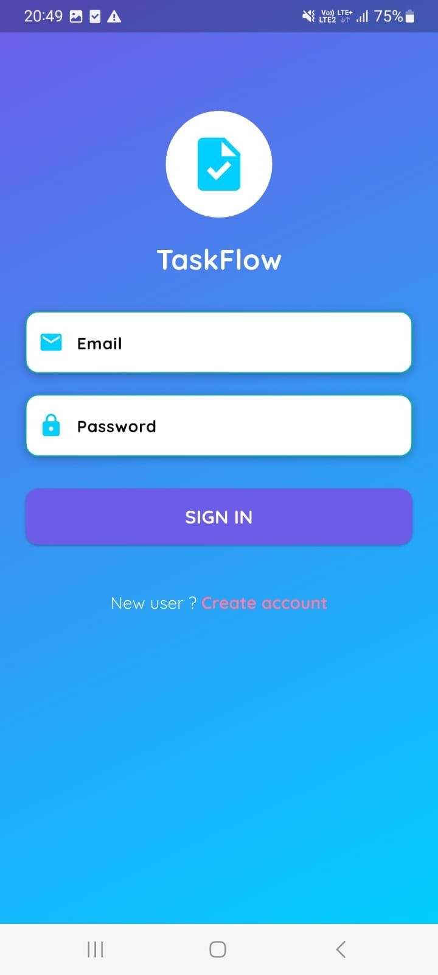

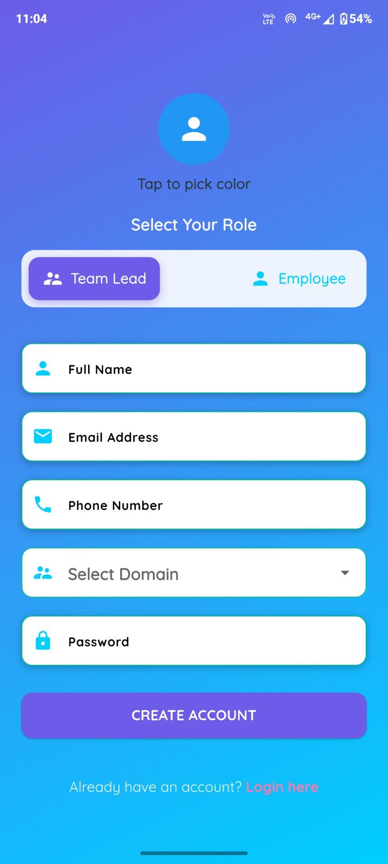

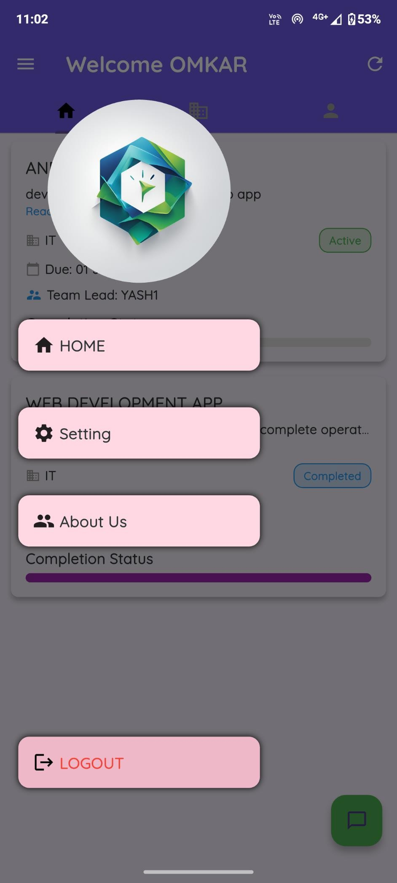

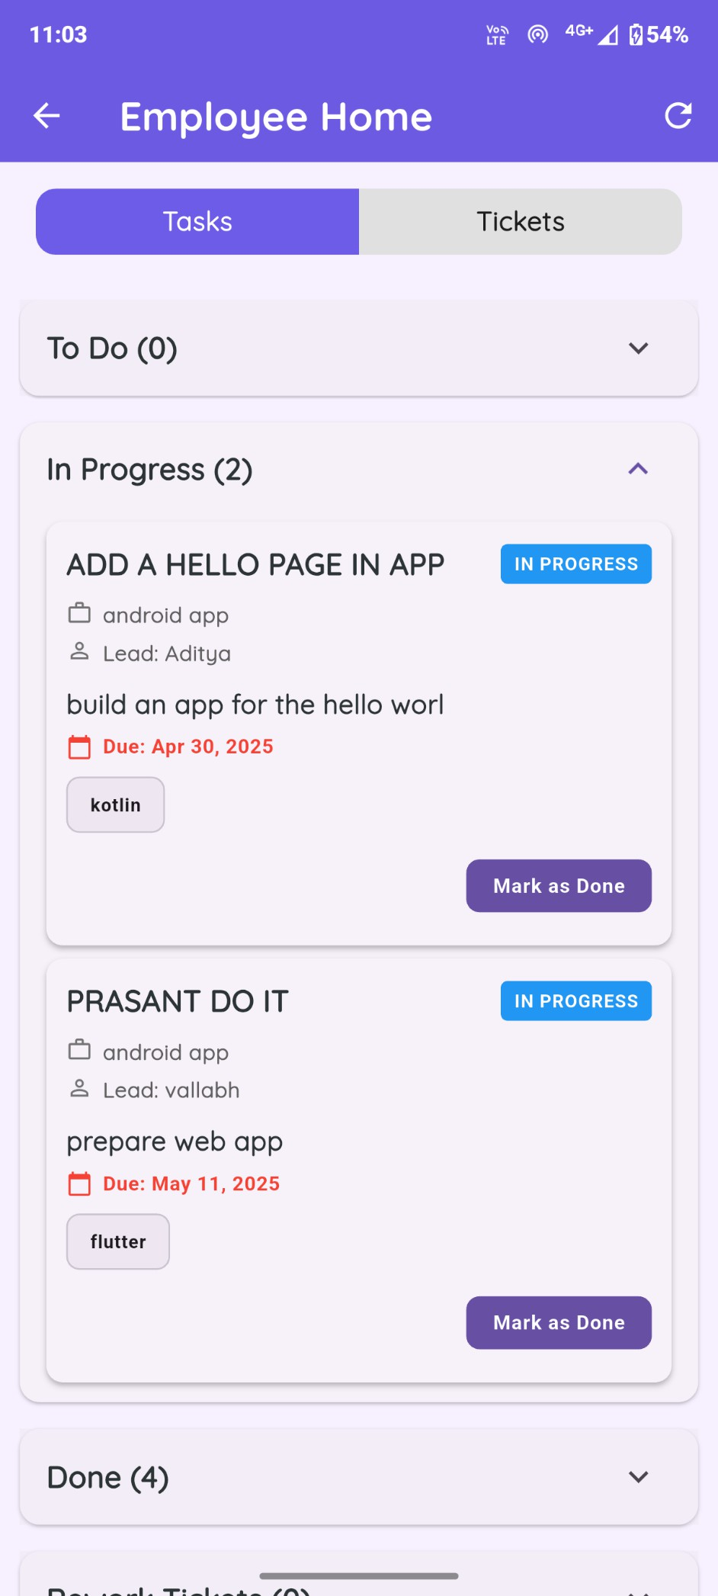

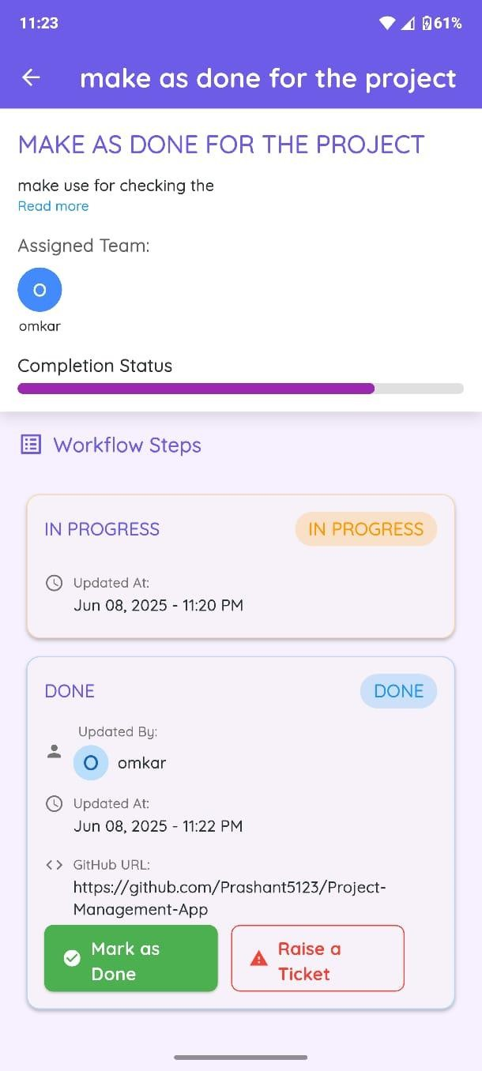

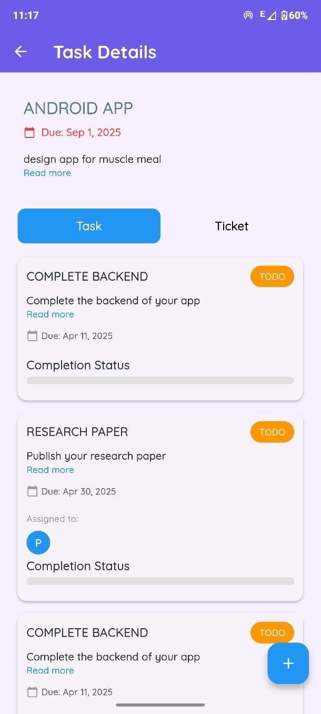

**CHAPTER 9**

**CONCLUSION**

## CONCLUSION

**The development of a cross-platform project management and tracking application is a significant advancement in modern project execution. In a fast-paced business environment, effective project management is essential, and this application aims to streamline collaboration among teams, ensuring alignment and clarity regardless of the devices used.**

**With features like real-time updates, user-friendly interfaces, and strong data security, the application addresses common challenges such as miscommunication and project delays. The integration of analytics and AI capabilities will allow project managers to make informed decisions, optimize resources, and enhance overall performance.**

**As organizations increasingly adopt remote and hybrid work models, the need for flexible tools becomes more critical. This application not only supports effective communication and collaboration across distributed teams but also caters to various industries, from corporate environments to educational institutions.**

**In summary, this cross-platform project management application is a strategic investment in improving project outcomes. By continuously evolving based on user feedback, it will foster collaboration, boost productivity, and help organizations succeed in a competitive landscape. The future of project management is promising, and this application is well-positioned to play a crucial role in that evolution.**

## FUTURE WORK

* + - **Advanced Analytics and Reporting :** Provides comprehensive dashboards and real-time performance metrics. Helps managers track project health, identify delays, and optimize resource allocation. Supports better decision- making through visual and data-driven insights.
    - **AI-Powered Task Management :** Leverages AI to recommend task assignments based on skills and workload.Automatically adjusts deadlines in real time to maintain efficiency. Minimizes manual planning and

enhances team productivity.

* + - **Integration with Popular Tools :** Supports integration with platforms like Slack, Trello, Jira, and Google Workspace. Enables seamless synchronization of tasks, communication, and file sharing. Improves workflow continuity without switching between tools.
    - **Enhanced Security Features:** Implements biometric authentication, encryption, and access control mechanisms. Protects sensitive project and user data from unauthorized access. Ensures compliance with data privacy standards and builds user trust.

## APPLICATIONS

* + - **Corporate Project Management :**Streamlines project planning, task d istribution, and progress monitoring. Enables efficient collaboration across multiple departments. Improves accountability and project visibility in corporate settings.
    - **Remote Team Collaboration :** Facilitates seamless communication and task coordination among remote teams.Supports real-time updates and centralized access to information.Enhances productivity regardless of team members’ locations.
    - **Freelancer Management :** Helps manage freelancers by organizing tasks, timelines, and payments. Provides a unified platform for tracking external contributors. Improves transparency and simplifies contractor oversight.
    - **Educational Institutions :** Assists educators and students in handling academic projects and assignments. Enables better group coordination and task tracking. Promotes collaboration and responsibility in academic environments.
    - **Startups and Small Businesses :** Offers an affordable tool for managing limited resources and projects. Simplifies operations without needing complex IT systems. Supports scalability as the business grows.

# APPENDIX A

### PROBLEM STATEMENT

Businesses and organizations face challenges in managing projects due to inefficient task allocation, communication gaps, and limited progress tracking. Managers struggle to assign projects effectively, while team leads lack structured tools to delegate tasks and monitor completion. Employees often lack clarity on task priorities and deadlines, which can lead to delays. This project aims to create a cross-platform application to streamline task assignment, tracking, and communication, ensuring efficient project completion and improved accountability across all roles.

### FEASIBILITY ASSESSMENT

#### Technical Feasibility :

* + - Flutter is used for the cross-platform front end to ensure compatibility with both Android and iOS. That gives the reduction of development time.
    - Firebase supports real-time updates, which makes it ideal for tracking live progression and data synchronization.
    - Authentication and safe data storage using Firebase Authentication and Firestore enable security and scalability.

#### Economic Feasibility :

* Firebase has a cost-effective structure; the free-tier options allowed that gave a high feasibility for the development and initial testing without high initial costs.
* Flutter saves the developers from the expenses incurred while developing a different version of the codebase to deploy the applications onto the various operating systems.

#### Operational Feasibility :

* As the present demands are for streamlined project management

that suits the existing scenario of the educational setting, it becomes simple and smooth to adopt.

* The role and roles within the system and their definitions from manager to the team lead employee mirrors most the structures that exist in any institution, as well as the roles associated with specific functionalities.

### SATISFIABILITY ANALYSIS:

* The problem of task assignment and tracking can be examined as a

#### Constraint Satisfaction Problem (CSP) where:

* + Constraints include deadlines, resource availability, and task dependencies.
  + Each role (manager, team lead, employee) has specific constraints in terms of task creation, assignment, and tracking.
* CSPs are typically solved by algorithms that iteratively evaluate the feasibility of a solution within given constraints.

### COMPLEXITY ANALYSIS (NP - HARD, NP- COMPLETE OR P) :

* The core operations (task assignments, progress tracking) in your project could be mapped to **Job Scheduling Problem** models, commonly analyzed within computational complexity theory.
* In a simplified case without intricate dependencies or resource allocation constraints, this would be a **polynomial-time (P-type) problem**, allowing efficient solutions.
* If there are additional constraints such as multiple interdependent tasks, deadlines, or limited resources per employee, the problem can become **NP-hard**. This is due to the combinatorial nature of determining an optimal schedule that satisfies all constraints (similar to the **Partition Problem** or **Knapsack Problem**).

### MATHEMATICAL MODEL AND MODERN ALGEBRA :

* **Set Theory :** Define each role (manager, team lead, employee) as a set of permissible actions. For instance, a manager’s set

includes (assign projects), a team lead’s set includes (divide tasks , assign tasks), and an employee’s set includes (track tasks, update progress).

* **Graph Theory :** Tasks can be represented as nodes and dependencies as directed edges. **Graph traversal algorithms** (e.g., Depth-First Search) can determine task dependencies and detect cyclic dependencies, which are critical for ensuring task completion feasibility.
* **Boolean Satisfiability (SAT) :** Representing constraints as Boolean expressions, such as whether all tasks assigned to employees meet their deadlines, allows the problem to be analyzed using SAT solvers, which are suitable for NP-hard problems.

# Appendix B : Research Paper

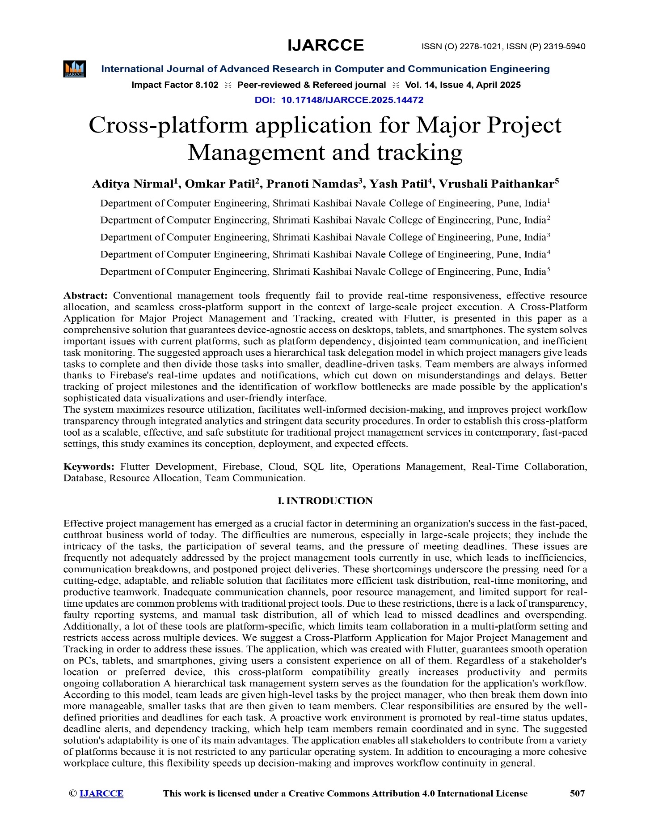

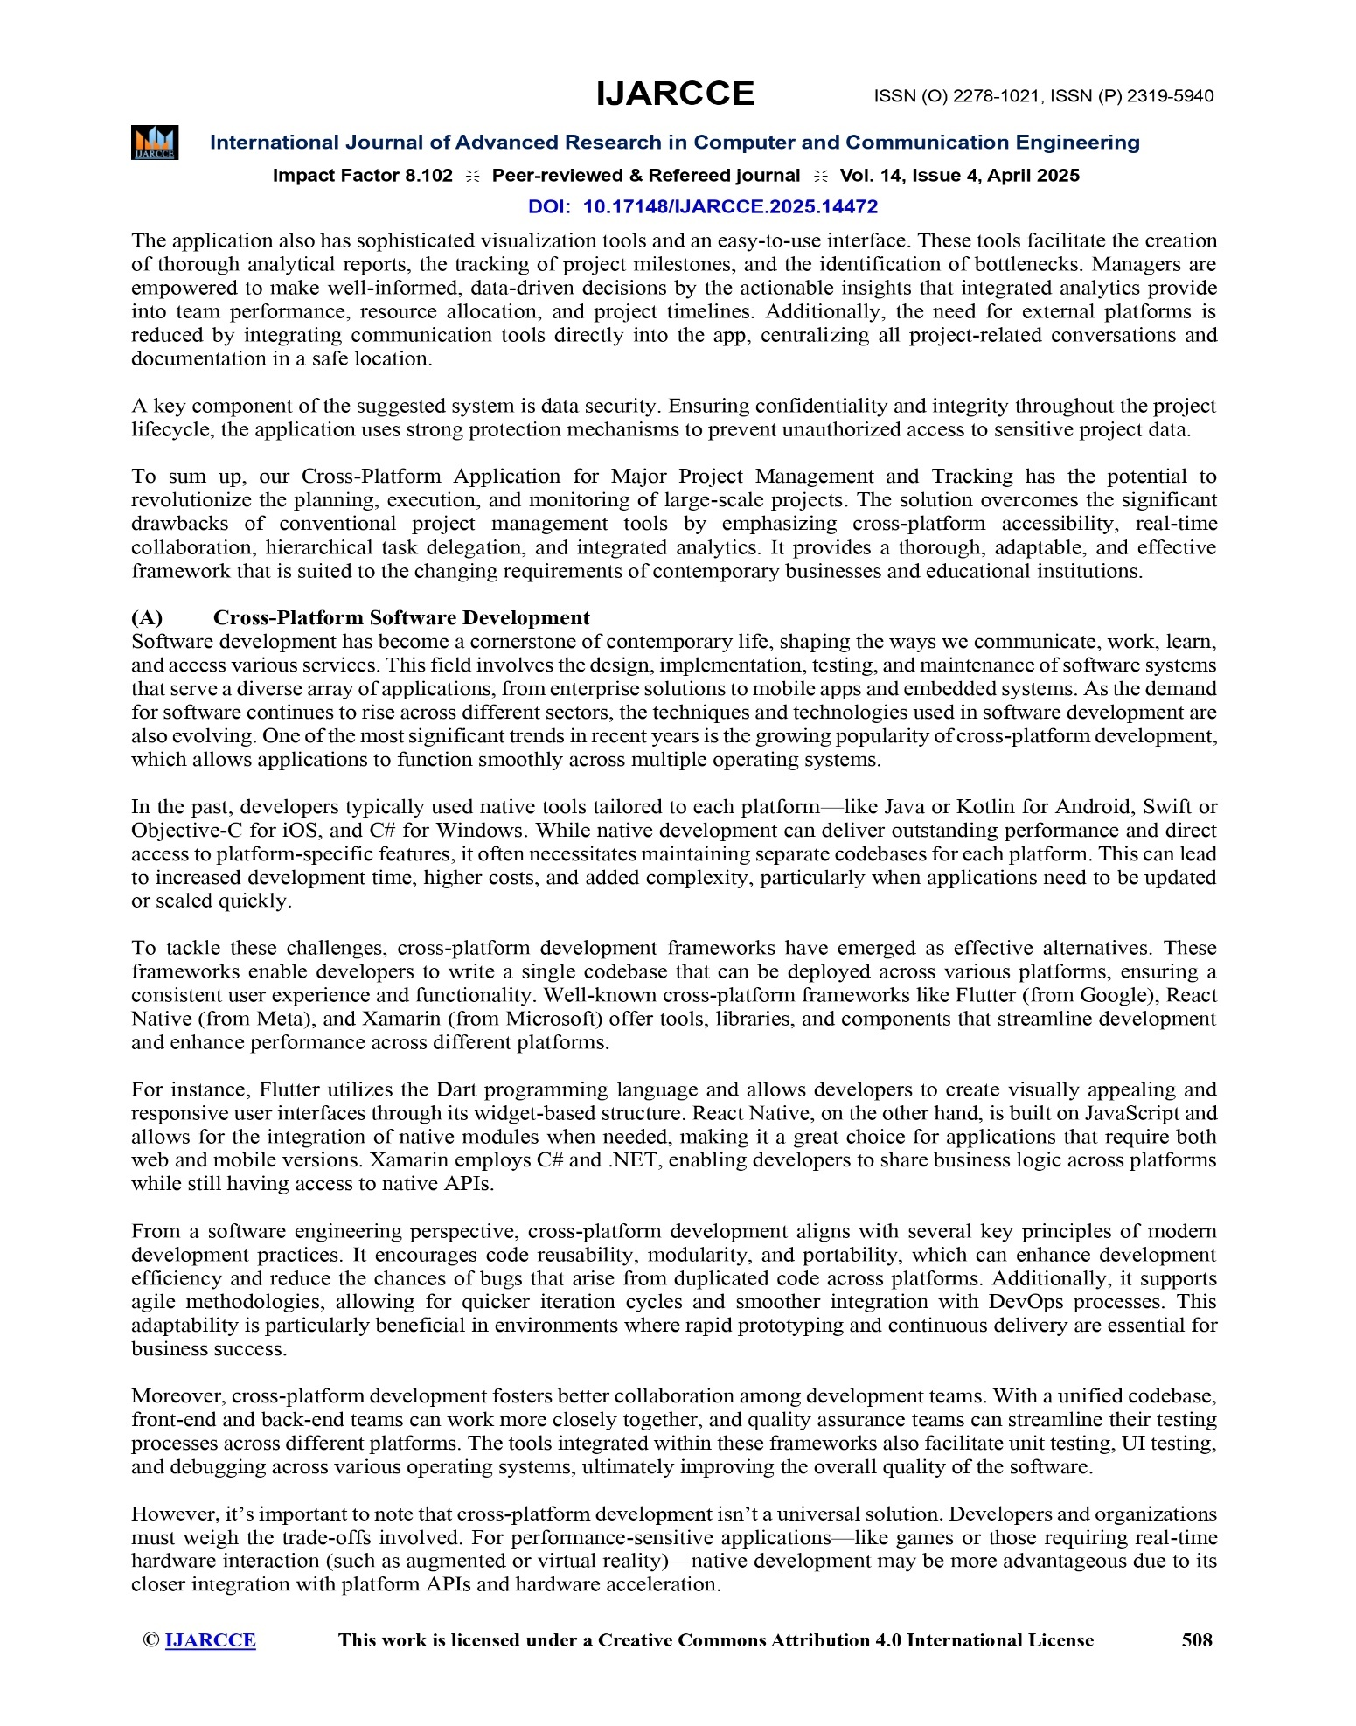

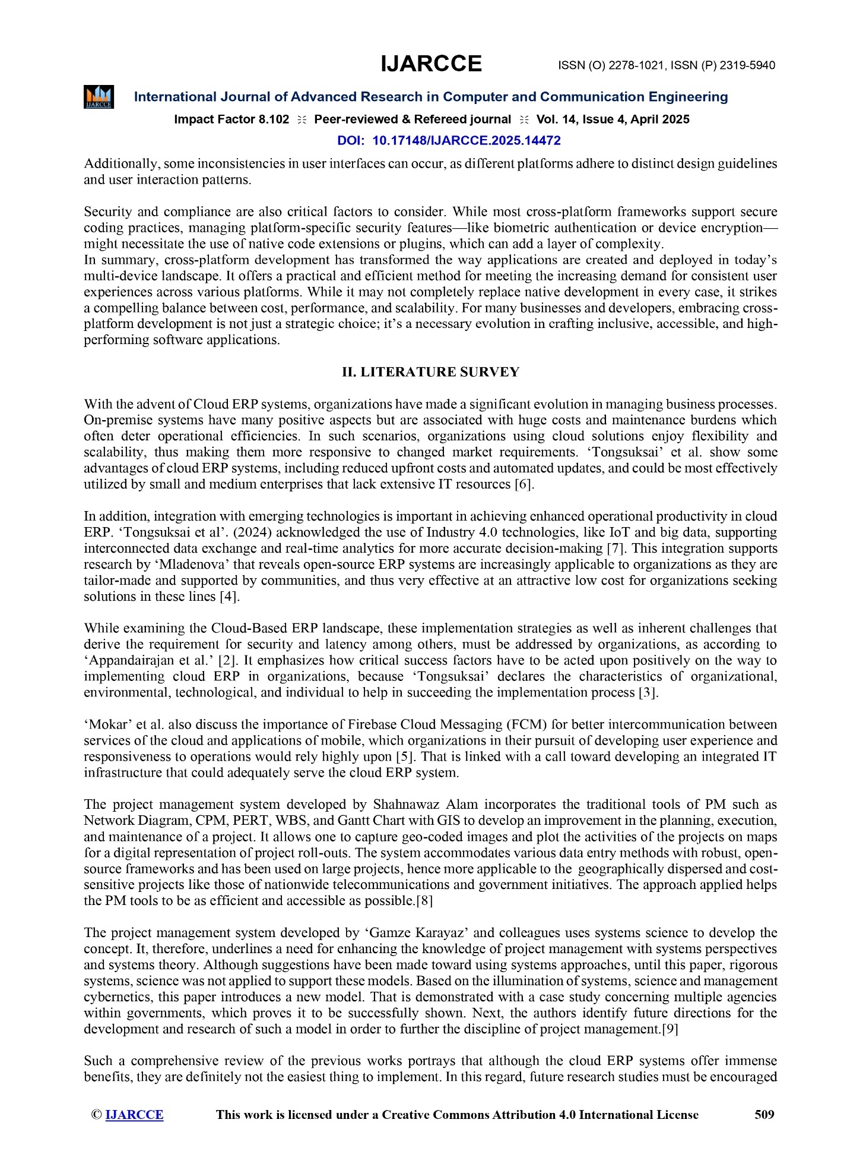

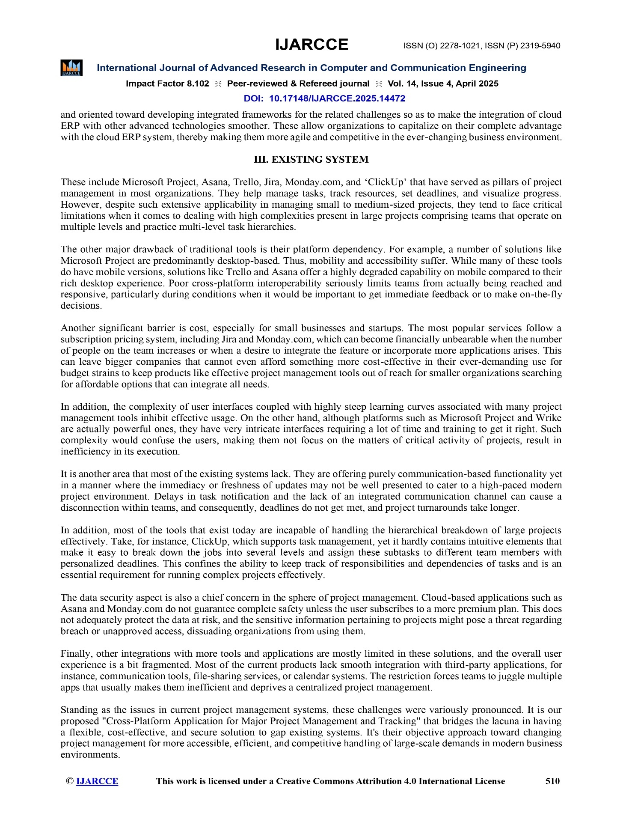

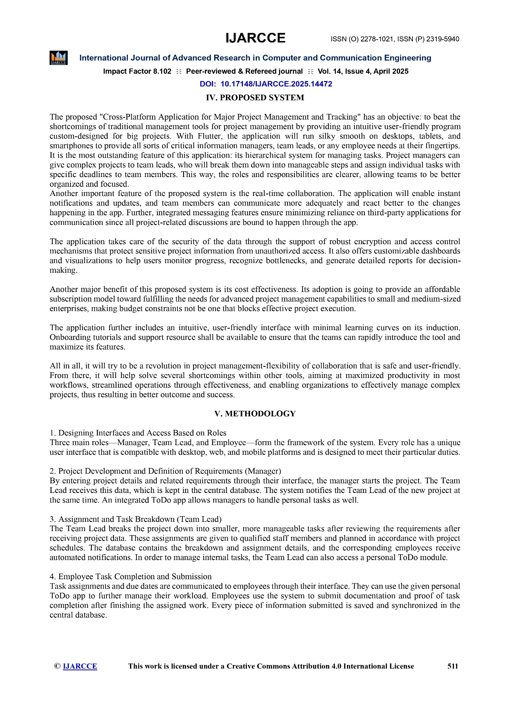

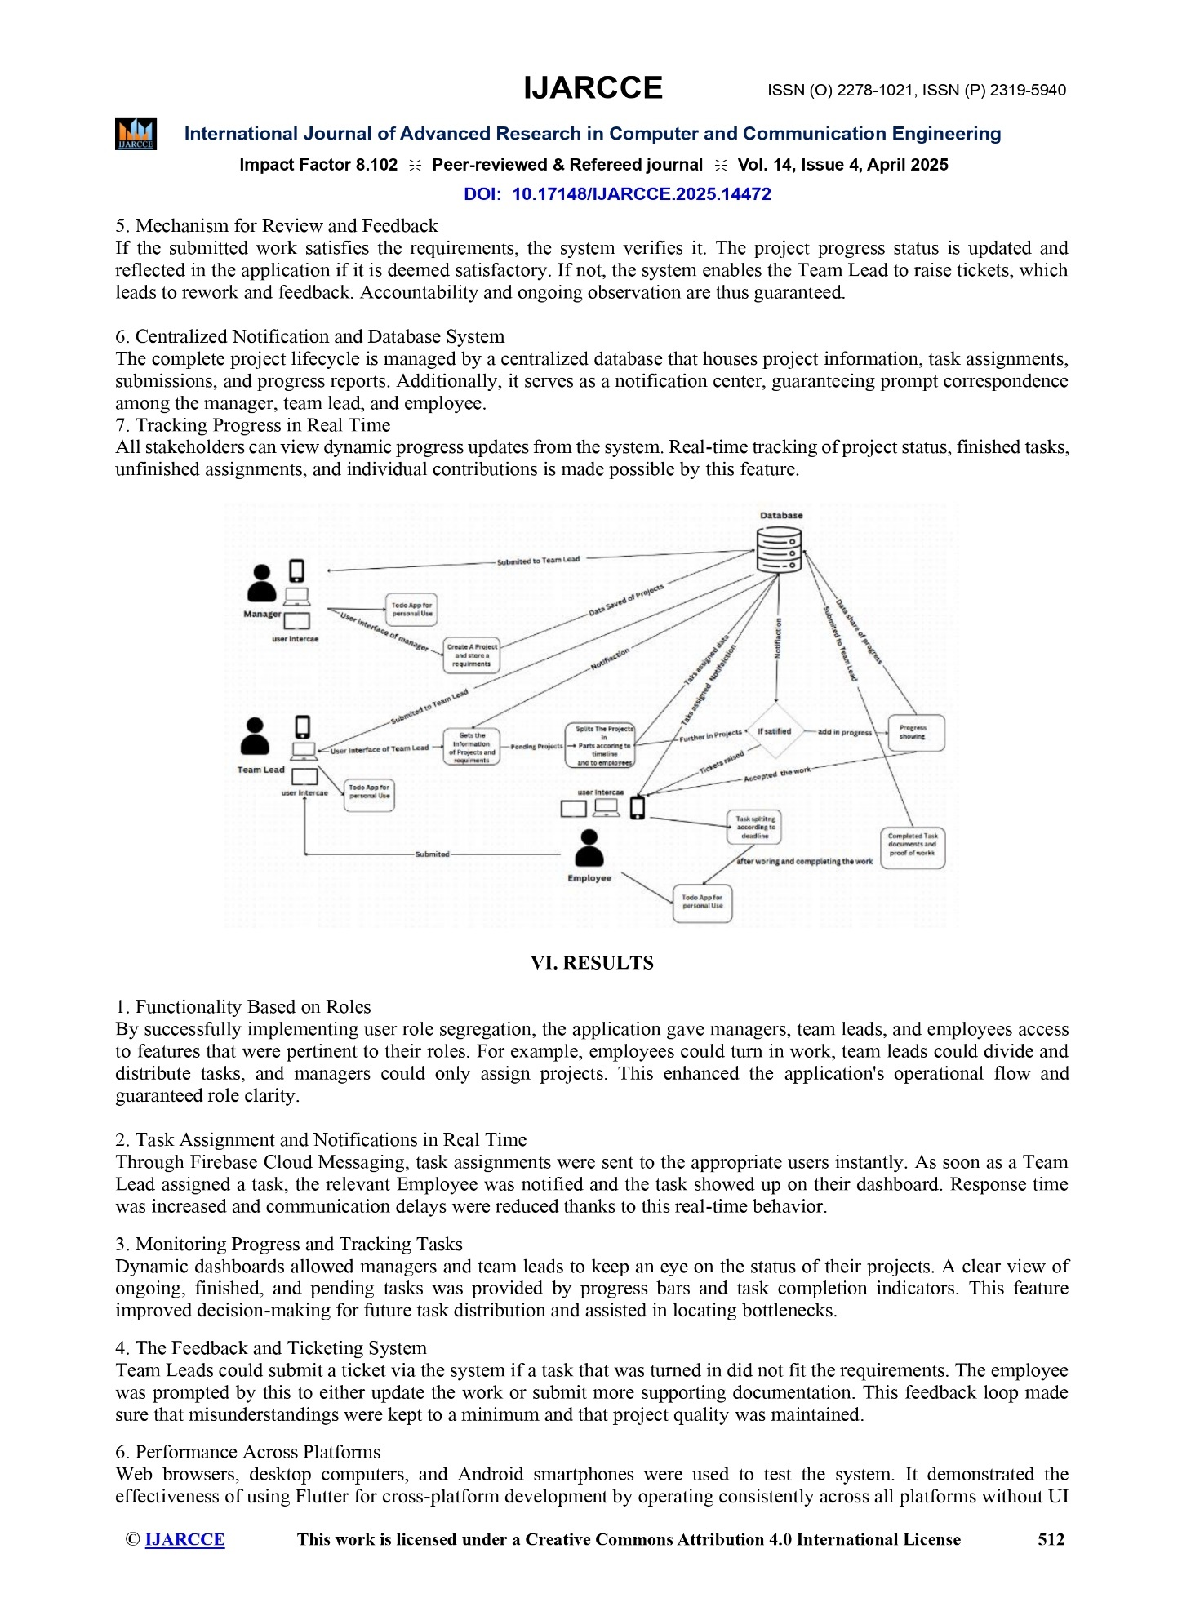

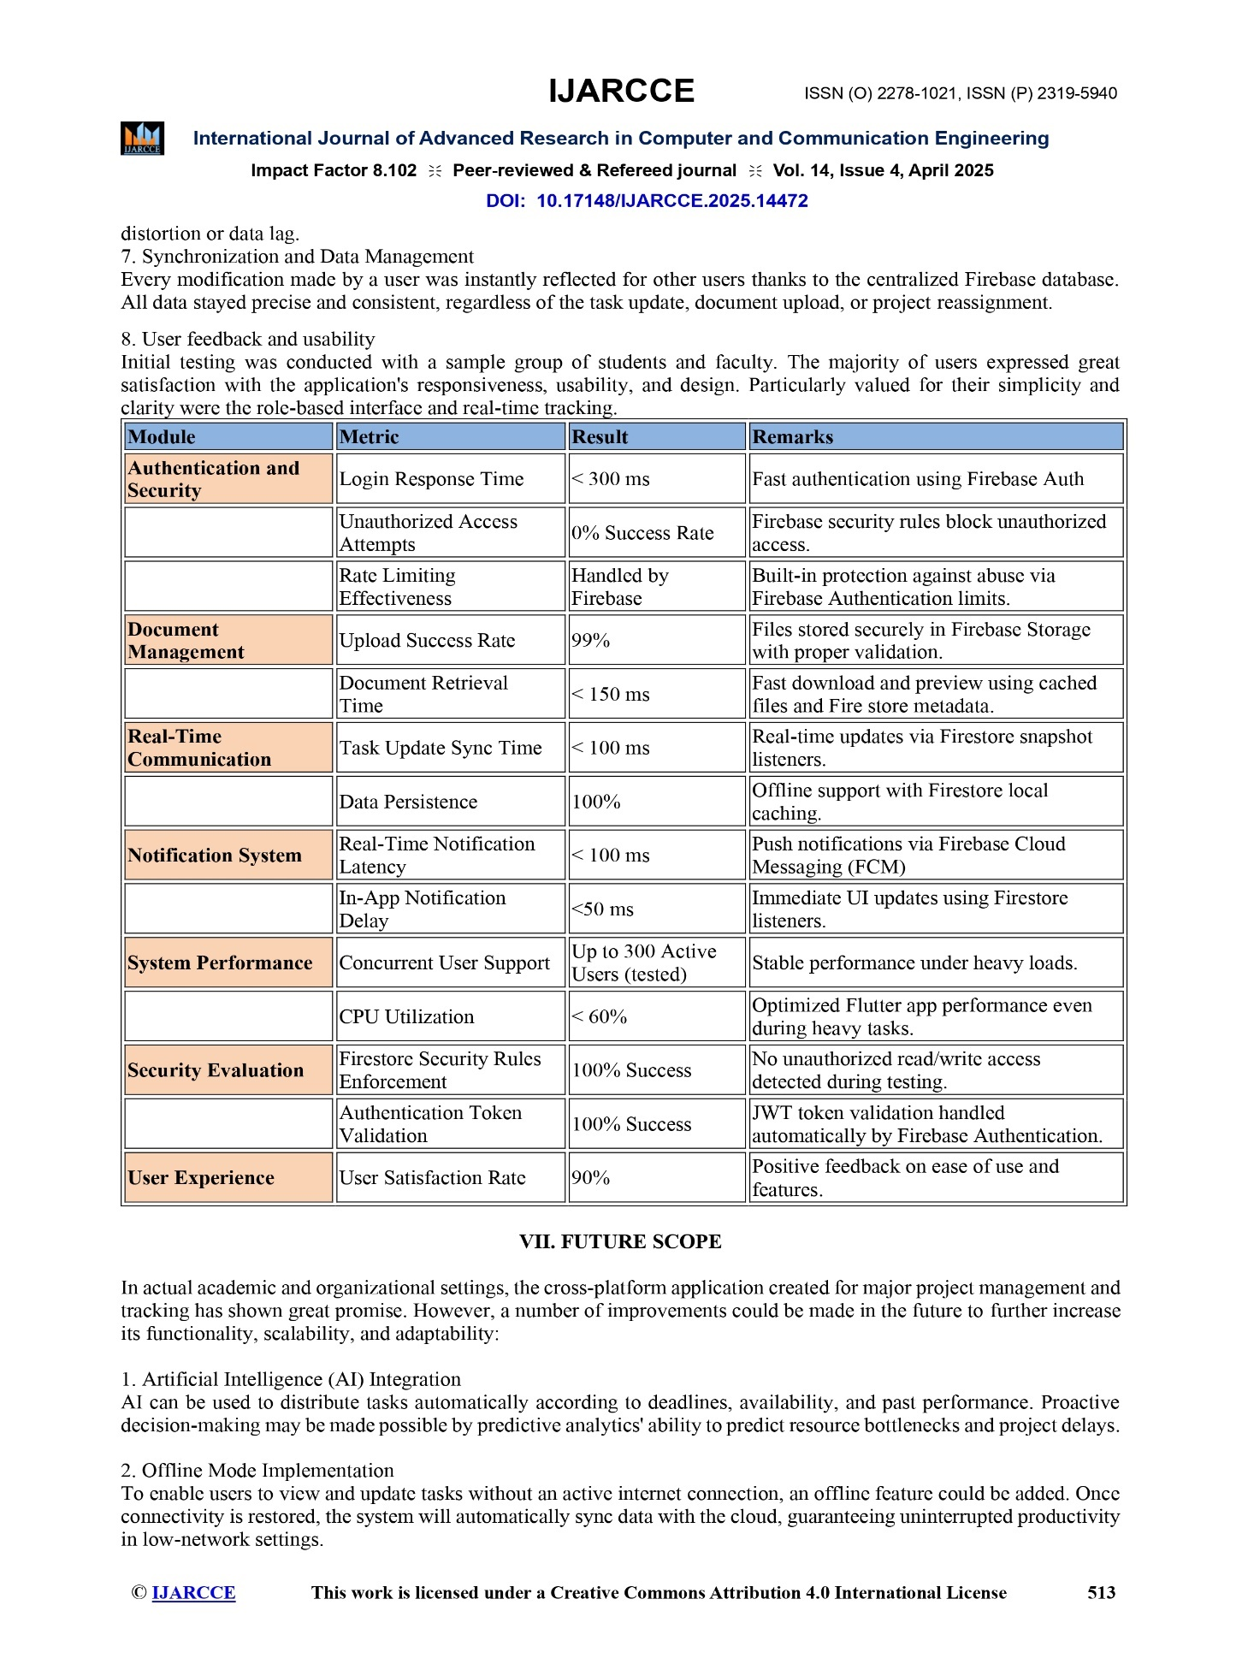

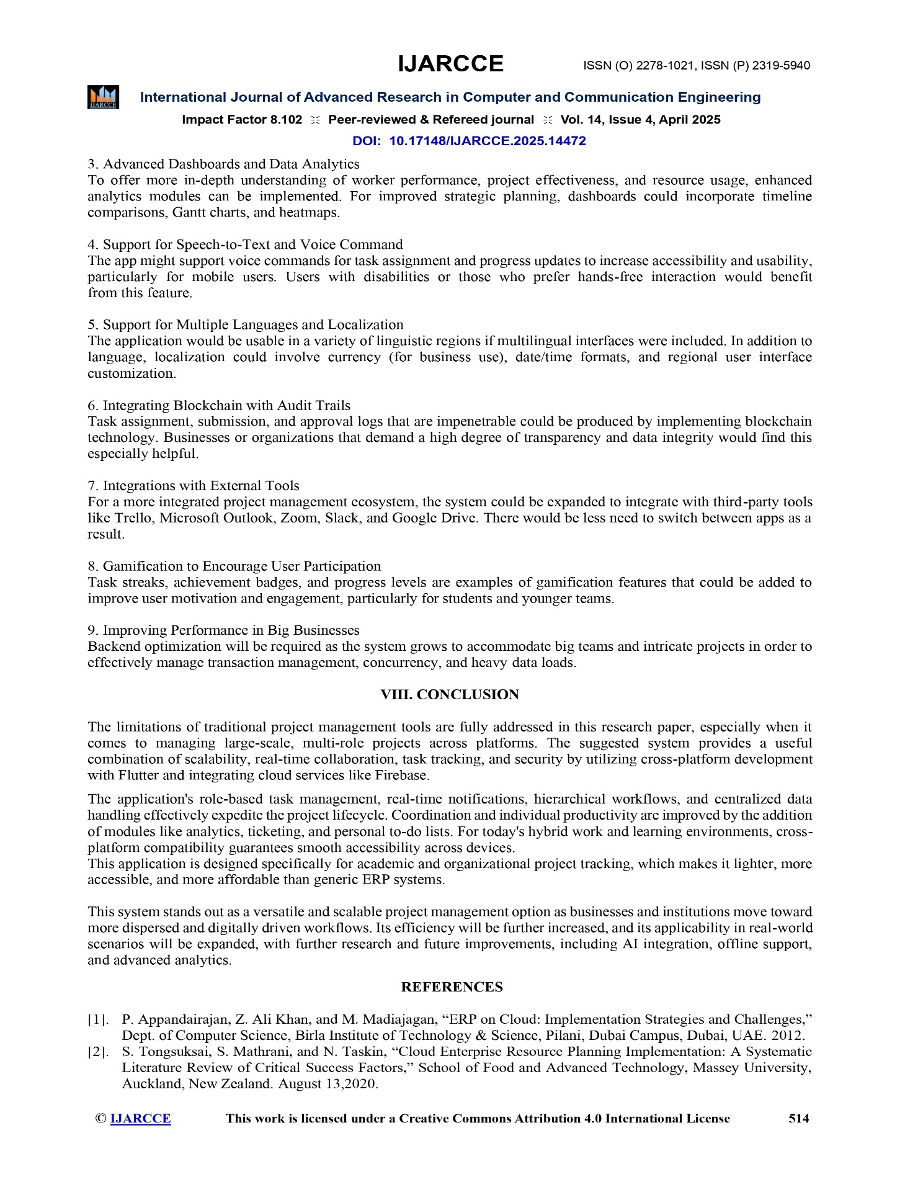

# 

# Appendix C: Plagiarism Report

# 

This appendix contains the plagiarism check results for the Cross Platform Application for major project management and tracking project report. The plagiarism report ensures that the content provided in the project is original and does not infringe on any existing works.

## Plagiarism Check Overview :

* **Tool Used:** Turnitin
* **Date of Check:** 2 May 2025
* **Total Word Count Analyzed:** 5,072
* **Percentage of Unique Content:** 97%
* **Percentage of Similarity:** 3%

## Areas with Similarity

* No areas of similarity were found, ensuring that the entire report contains 100% original content.
* The plagiarism check confirms that the content of the cross platform application for major project management and tracking project is entirely unique and free from any copied material.

**CHAPTER: 10 REFERENCES**

1. P. Appandairajan, Z. Ali Khan, and M. Madiajagan, “ERP on Cloud: Implementation Strategies and Challenges,” Dept. of Computer Science, Birla Institute of Technology & Science, Pilani, Dubai Campus, Dubai, UAE. 2012.
2. S.Tongsuksai, S. Mathrani, and N. Taskin, “Cloud Enterprise Resource Planning Implementation: A Systematic Literature Review of Critical Success Factors,” School of Food and Advanced Technology,

Massey University, Auckland, New Zealand. August 13,2020

1. T. Mladenova, “Open-source ERP systems: an overview,” Department of Computer Systems and Technologies, University of Ruse, Ruse, Bulgaria. May 20,2021.
2. S. Tongsuksai, and S. Mathrani, “Integrating Cloud ERP Systems with New Technologies Based on Industry 4.0: A Systematic Literature Review,” School of Food and Advanced Technology, Massey University, Auckland, New Zealand. June 03,2021.
3. M. Mokar et al., “Communication Technologies in CloudBased ERP,” Institute of Computing, University of Technology.2021
4. Z. Ali Khan et al., “Challenges in Implementing CloudBased ERP Systems,” Journal of Information Systems and Technology 2022.
5. Mohamed Mokar, Sallam Fageeri, Sai Fattoh, “Using Firebase Cloud Messaging to Control Mobile Applications”, 2019 International Conference on Computer, Control, Electrical and Electronics Engineering, May 05,2020.
6. S. Jain and K. Chandrasekaran, “Industrial Automation Using Internet of Things,” in Security and Privacy Issues in Sensor Networks and IoT, IGI Global, 2020, pp. 28–64.
7. N. Chatterjee, S. Chakraborty, A. Decosta, and A. Nath, "Real time Communication Application Based on Android Using Google Firebase," Int. J. Adv. Res. Comput. Sci. Manag. Stud, 2018.
8. A. Rahmi, I. N. Piarsa, and P. W. Buana, "FinDoctor Interactive Android Clinic Geographical Information System Using Firebase and Google Maps API," International Journal of New Technologyand Research, vol. 3, 2017.